V2 Revision Stage
Group 6: Team Pinpoint
Andy Hoang, Citlally Vasquez, Darrel Dennis, Max Ju, Troy Waters, Wai Soltow
Milestone 3 Written Report
Introduction:
Recap:
Our initial concept was to create a local focused social media program where people can post freely about anything, where visibility of posts are tied directly to the closeness to the user. This initial concept was rooted in the belief that hyper-localized content could foster stronger community connections and make it easier for users to discover events and interact with their local community. We prioritized proximity, ensuring that users would see posts relevant to their local surroundings. That initial conception guided our questions and interviewing process.
From the user-centered design research we refined the project idea to as follows. The app will contain 3 main pages the user can select from. The “Board” page, the Map page, and the Chat page. The app’s main screen is an “infinite feed” of unique Pins where users may continue scrolling to see Pins posted by others sorted by distance. Inspired by forums much more common in the earlier days of the Internet, our Pins functions similar to a typical internet forum’s thread system. Pins may include an image or no image, and a necessary text submission alongside it. If a Pin interests a user, they may click on the Pin to open up that Pin page which may include more details about the event, as well as replies.
The Map section of the app will include a standard Mercator projection map where users may interactively see what Pins are close to them. This includes zooming in and out, pressing on Pins, and viewing. The entire map of the world will be present, but the pins that are visible will still be constrained to a local area. Users may not see Pins that are too far away from their current location.
Lastly, we have a Chat page. In this page there will be a free flowing chat where message visibility is constrained by how close messages are to the user’s current location. Users may send out messages into the chat, and only those within the users’ radius may see those messages.
Significance of Market Research:
The market research conducted through 17 interviews was instrumental in shaping the direction of the project. From the pain points and concerns, we are able to get a better idea of what users can get out of our app. Through our user interviews and analysis, we identified pain points in communication, such as over-reliance of word of mouth, fragmented small group communities, and lack of intuitive tools for event discovery. In addition to those pain points, we identified the following concerns. Interviewees had concerns over location tracking, data sharing and selling, event legitimacy, and content moderation.
Over-Reliance on Word of Mouth was cited as an issue for interviewees. This pain point legitimized the need for an easy place to post local event information without the stress of being seen worldwide. Our platform serves as a centralized place to post and discover local events. Allowing users to easily create Pins with images and supplemental text, this affords users great freedom in how they want to express themselves with their local community.
Small group communities are fragmented. Interviewees spoke about how they are part of many groups but must keep track of several different events through different means. This concern informed our design by being a single unified space for seeing local events.
Lack of Intuitive Tools for Event Discovery was a commonality between participants in our market research. Our answer to this pain point was to create a map of pins. This map tool affords the user intuitive event discovery. In addition to our map tool, sorting by distance in the Board section helps alleviate some of the analysis paralysis that comes with discovering the events in a locality.
Interviewees also spoke on Concerns Over Event Legitimacy. Our approach to this problem is two fold. We intend to combat this issue by requiring users to sign up with phone number verification. This ensures that events are posted by real people, and adversarial attacks against the system are much harder to scale. In addition to phone number verification, we also intend to add event attendance tracking to allow users to gauge event interest.
Lastly, interviewees had Concerns Over Content Moderation. This insight helped guide us towards a 3 pronged approach. First, users may report harmful posts which will be reviewed by moderators. Secondly, we intend to add automated content filters to block obviously harmful content and spam. Lastly, we intend to add Clear Community Guidelines to help users reference what is allowed content on the app.
These pain points and concerns guided us to address what users truly need to enhance the local interaction space. By tackling issues such as fragmented communication, lacking event visibility, event legitimacy, and content moderation, we’ve designed a solution that will provide value to users in discovering local happenings and events. The insights over concerns with the app concept have been invaluable to the current design and what problems need to be addressed before shipping the application out into the world. Moving forward, these discoveries will serve as a foundation for our project as we continually iterate this project. Our refined solution will bridge the gap between the current state of local communication.
Market Overview:
Market Size and Growth Trend:
Some competitors that more closely compete in the local event sphere are private and thus will be difficult to ascertain metrics on. In light of that, some general purpose social media apps are included to demonstrate general market size and growth trends.
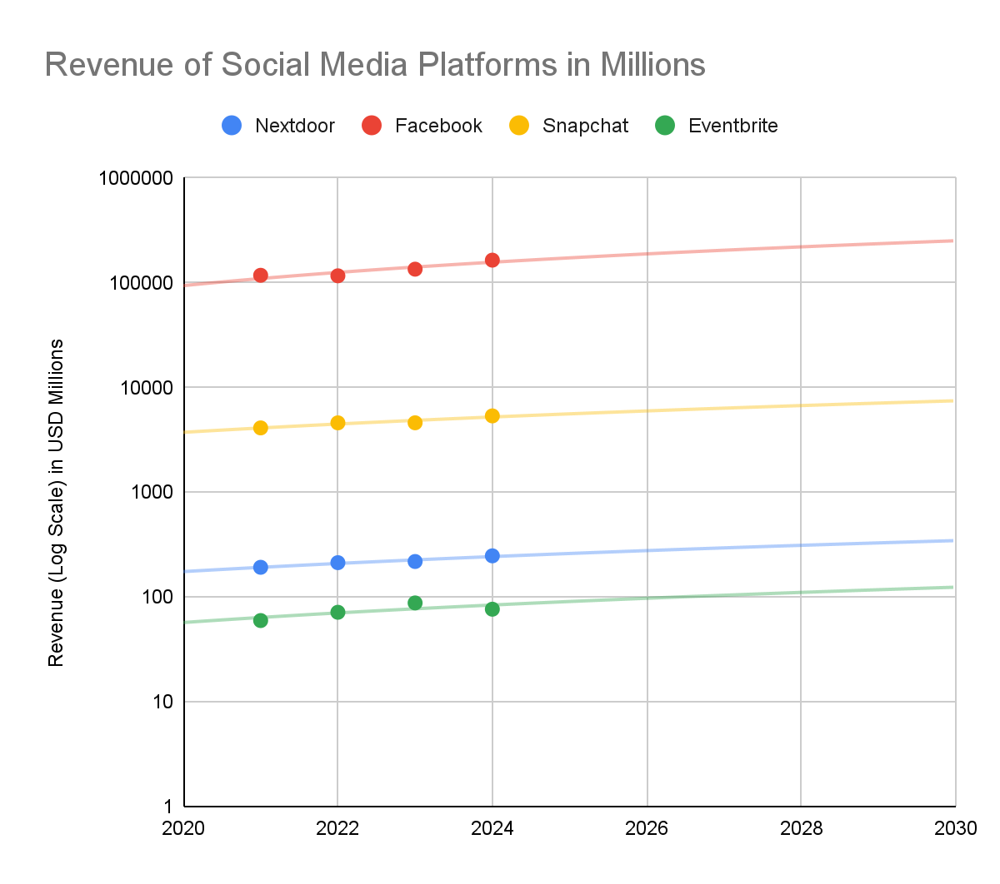
The graph above displays a straight best fit line over the logarithmic revenues for each company in the list. In a logarithmic graph, that a straight best fit line indicates exponential growth for all of the companies listed.
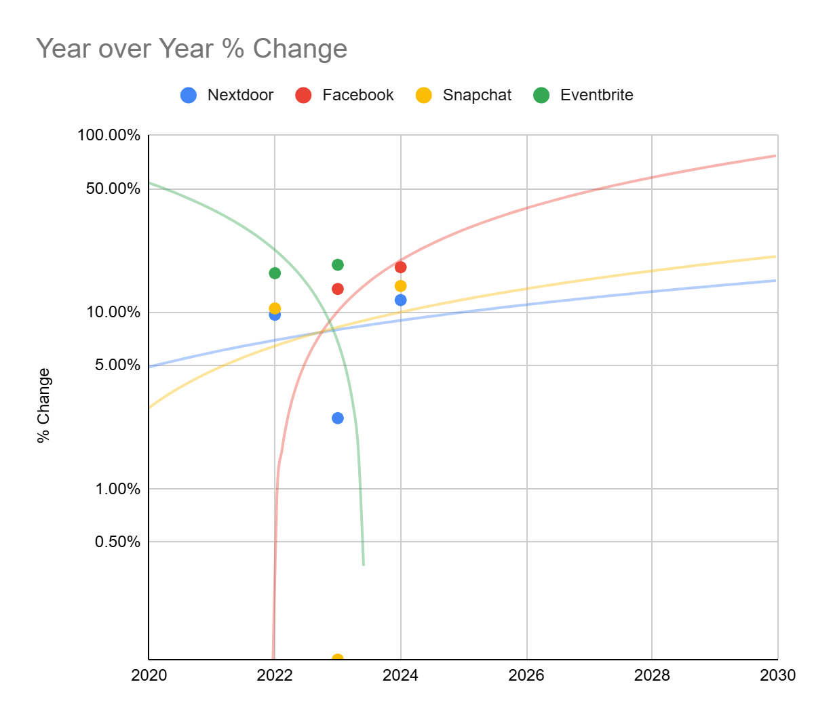
In this graph of Year over Year % change, we can see that Facebook, Snapchat, and Nextdoor have a convex upward curve best fit line. This indicates that the growth of these companies is increasing, but the rate of growth is decreasing, meaning they are reaching market saturation. Eventbrite has a concave down and decreasing best fit line. This indicates that revenues are decreasing at an increasing rate over time.
Major Players and Market Share:
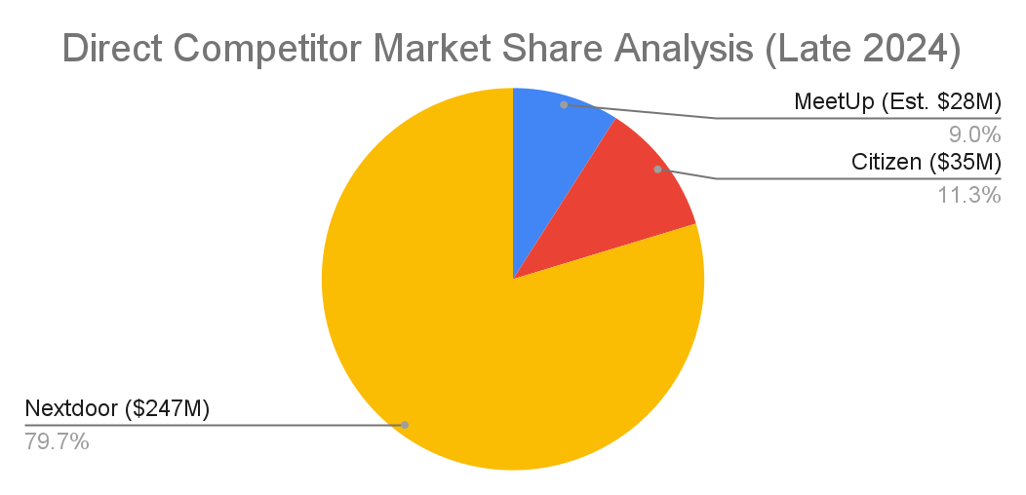
General Observations:
The market for local communications apps is difficult to determine, as specific data on these apps are limited. This type of app is essentially a subset of the various communications apps such as Nexdoor, Citizen, or Meetup, which means that whatever happens in those markets there, will also likely affect the market for the local communications apps.
During our research into the local communications app niche, we discovered the combined market capitalization for the 3 largest apps totals to about $310 million USD (Nextdoor, Citizen, and Meetup). Nextdoor was the largest of the 3, valuing at around $247 million, which is almost 80% of the local communications market. Their value was a sizable increase from the last year, with a 13% increased revenue from the previous year. As for Citizen, it was valued at an estimated $35 million, and for Meetup, it was valued at about $28 million.
Currently, the market for global and local social networking, instant messaging, and mobile messaging apps all show a promising future for this market. As of right now, the market for all of these apps are valued at billions of dollars in total. Not only that, they are also showing no signs of slowing down in the future either. This is because of a combination of multiple factors; people wanting local integration, user privacy, and community.
Direct Competitor Analysis:
Application Features | Meetup | Nextdoor | Citizen
Location-Based Events | ✅ Yes | ❓Just post, not events | ❓Only for Emergencies
User Events | ✅Yes | ✅Yes | ⛔Only Crime Reports
Visual Map Feature | ⛔No | ❓Only Lost and Found | ✅Yes, for current incidents.
Anonymous Options | ⛔No | ⛔No | ❓Partially, only alerts
Local Chat | ✅Yes | ⛔No, Voting only | ⛔No
Image Sharing | ✅Yes, for Event | ✅Yes | ✅Yes
Mobile Application | ✅Yes | ✅Yes | ✅Yes
Verification | ✅Organizer Discretion | ✅Real Name and Address | ✅Verifying Reports
Self-Destruct Messages | ⛔No | ⛔No | ✅Yes, alerts fade.

It should be mentioned that Citizen isn’t so much a direct competitor, but more so the only other popular application for local communication. It comes with great surprise in such a short timeframe we found ourselves pulling for scraps. A lot of other competitors are more indirect: such as Facebook Groups or Telegram groups. To develop a full table of features against competitors who satisfy strictly the requirement of local communication is difficult to come by. Since applications tend to provide very broad tools, what defines a potential competitor is actually a very difficult question to answer.
Competitor Analysis 1 - Meetup:
Overview: Brief Introduction of Meetup
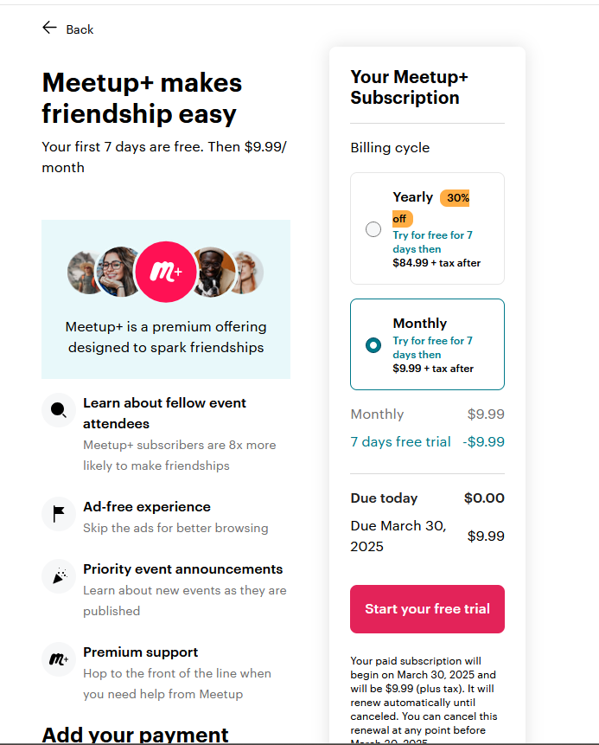
In 2002, a new website showed face on the internet to streamline the ever increasing connectedness of locals in their respective neighborhoods. At the time it was quite remarkable - smartphones wouldn’t be released for another 5 years and the word ‘app’ wasn’t part of everyday language. Instead of phone dialing all your neighbors and getting stuck in an undesired conversation for hours on end, you could simply plan an event on their website. Anyone could register and the service was free. Fast forward to today and now we have the mobile application. Join a local group, join the group's event, and meetup. However, unlike the original 2002 Meetup, current market Meetup comes with a lot more nuances which affect everything: from market growth to user experience, and to insights regarding the overall market of local citizen communication tools.
First Impressions: “Pay me $2.99 for a First Impression”
While first impressions can prove to be extremely insightful in the nature of what an application is, presenting this image of subscription fees will largely carry this first impression. For context, the option “Try for $2.99/month” and “Try for Free” both lead to the same page. Before we have seen the application the user is presented with the illusion of choice and is required to give their credit card information. From a security standpoint this makes a lot of sense. Telegram and Discord both have automated bot problems since accounts are free. However, the user hasn’t even seen the application yet! What does the user interface look like? How does it work? What does the application look like in action? Most individuals are well aware of the fact that companies exploit user forgetfulness to unsubscribe before the next billing statement. Needlessly to say, but users have to pay money for a first impression.
Usability and user experience insights
Before a user can even browse, they must join a group. All events are tied directly to a group. To begin browsing, it’s ideal then to simply join as many groups as possible, as nearly all posts require being in the group to see. Meetup works in a more classic manner in simply giving users the address of the event, but no visual map indicating where the event might be. This can be quite problematic when planning events at parks where you may give out the address of the parking lot, but not the actual reserved location for the event. But overall the application is straight forward: plan an event, drop the address to everyone in the group, and off they go.
Taking our first step into the reviews on the Meetup app, we are immediately bombarded with feedback. Users can’t login with their Google account, the application freezes, and trying to make a new account results in “an account already exists for that.” Should a user get past this bumpy start there’s the fact the application requires permissions. But apparently giving the Meetup application full permission to use a phone's built-in Calendar system doesn’t work. So does Meetup require even more permissions just to add events to the user calendar? There is no further clarification as to why such a simple feature doesn’t work. So, let’s take a moment to zoom out from the swamp of complaints on basic features not working and discuss money.
Money may make the world go around, but money verifies you’re real on Meetup. The topic of verification has been brought up extensively: whether it’s by 2-factor authentication, age verification through a government tool, or moderator approval by sending pictures of your driver's license. With money on Meetup you get higher priority in waitlists. You want to be able to send multiple messages to a friend in a single day? Money will let a user do that. Want to check who is going to the event? That last question requires breaking professionalism for a moment. Having to spend money to find out who's attending your own event is atrocious and highly suspicious. If a user can’t obtain even the most basic information on who's attending an event, then that’s simply exploiting the user's ignorance. This design philosophy borders on exploitation, since paying for basic information is a major ethical and accessibility concern.
Standout features or notable gaps
Observation of past overwhelming user frustrations isn’t without merit. As one might guess, Meetup is a competitor from a technical perspective. In fact, Meetup’s last popularity spike was in 2012. Finding standout features on Meetup proved difficult because the market has drastically changed in the last 10 years. Perhaps in 2012 it proved to be the best solution. But now it pales in comparison to other companies who give tools exponentially more powerful - and without the paywall. When Nextdoor (the next competitor) and Meetup are removed from the equation, we get a surprising result: nothing. But nothing means there’s a gap in the market. During the team’s presentation it was discussed how there’s an oversaturation in the market. This is primarily the result of indirect competitors who may not specialize in local communication, but have tools that just happen to facilitate it. Tools for specialized local event planning simply don’t exist on a large scale, but perhaps it’s time for that change.
User Reviews & Ratings
(Below) Meetup: Average Review Scores Yearly. All countries.
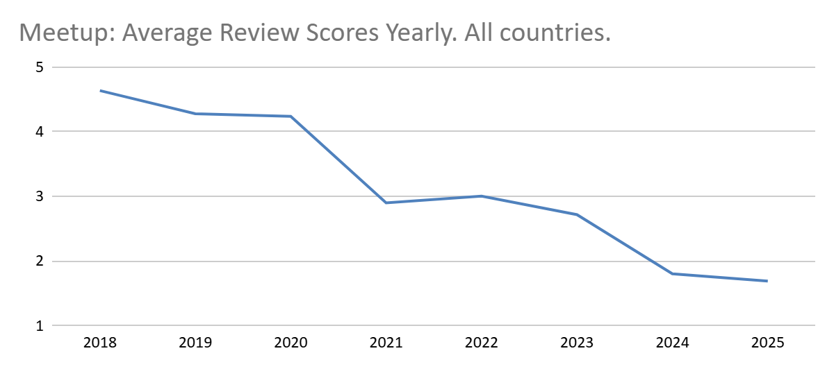

Meetup’s App User Scores. User Ratings from Last 5 Years, All Countries
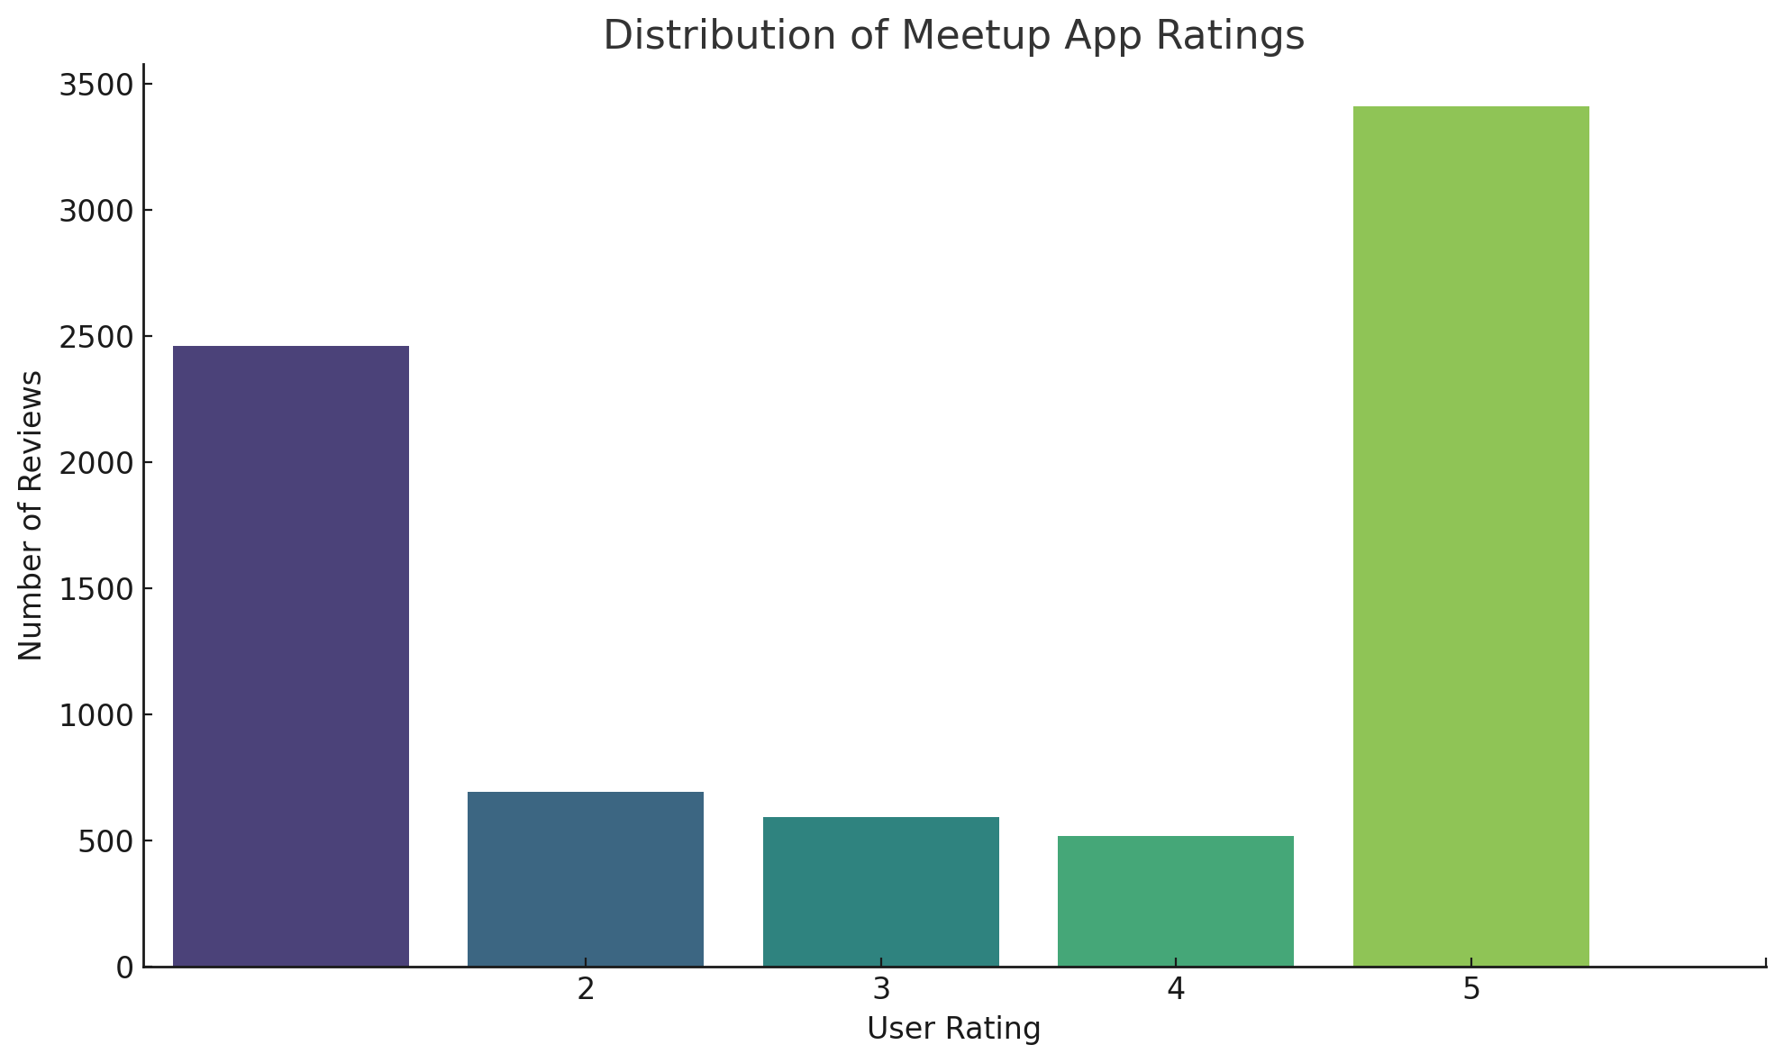
Meetup’s App User Scores. Last 5 years. United States only.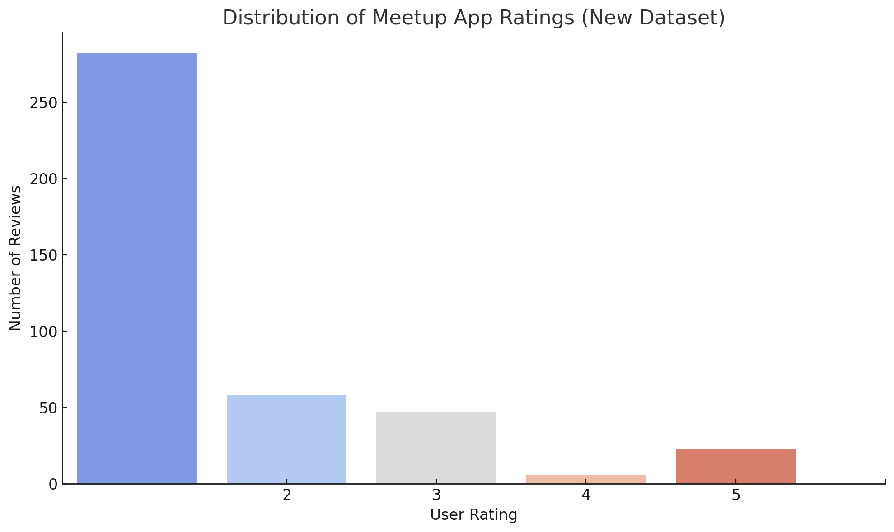
Competitor Analysis 2 - Nextdoor:
Overview: Brief Introduction of Nextdoor
Nextdoor was first created in 2011 with the intention of allowing neighbors to privately communicate with each other through a social platform, similar to Facebook and Instagram, which were on the rise at that time. . The website/app is a local, neighborhood app specialized in providing a private social network for residents to connect, share local information, and build community.
Features and Offerings
In the past decade, the website/app has gained lots of features within the app such as public group chats, ability to discover local businesses, meet others with similar interests, discover what events are happening in the area, and private “street” group chats. Within these street group chats, only verified residents within a block can enter the chat and interact with others. In these chats, locals can ask questions, share updates, buy, sell, or borrow items. Additionally, users can block each other, create posts similar to Instagram, and also see what topics/posts are trending in the app.
Hands-on Evaluation and First Impression
Upon further inspection, from the moment a user opens the site, it prompts the user with a simple “Log-in” or “Register” page. Once the user registers, a series of questions are asked such as “What’s your address?” or “What groups are you interested in?”. After an account is established, the site seems pretty easy to navigate. The menu/navigation bar showcases options such as Home, For Sale & Free, Chats, Notifications, Groups, Events, Invite Neighborhoods, and Post. There are also buttons that allow the user to view all posts that are Recent, Nearby, or Trending. As the user scrolls through their feed, they can view all sorts of posts ranging from people offering services, asking for recommendations, updating others on city events, complaining about loud vehicles, telling stories, asking for help when moving items, and a frequent topic was (lost or found) animals. In between posts, there are also lots of advertisements from local and non-local companies. Most mentioned services for remodeling or discounts/deals for department stores. Furthermore, the user can view all of their posts within their Profile section, and they can also earn rewards for making frequent posts that fall under that category, although there are no clear instructions on how to earn them. Some awards were “Biz Supporter, Convo Starter, Party Planner, and Visual Artist”.
All in all, the usability of the website seems very user-friendly and the navigation bar simplifies things by a lot. There you can access all features, the Post button is a bright green color, and you can explore other neighborhoods. Also within the groups section, people can easily create their own groups about any topic. Furthermore, most of the advertisements were related to home renovation and services for maintenance, but there were occasionally some irrelevant advertisements that mentioned webinars and other random services.
Stand Out Features
The “Events” feature that stood out. Within this section, there were some local events such as “Jigsaw puzzle swap/exchange” but there were also a lot that were random such as “Don’t let market volatility destroy your retirement”. Other events looked like they were clearly placed by businesses such as “Bites and Brews Happy Hour at ISM Brewing in Long Beach”. While it is beneficial for businesses to advertise themselves within the events section, it does not show a true representation of what the community is interested in. If a user were to propose meeting up at a business and hanging out there, it would show initiative to hang out rather than a business planting an event. Similarly, most of these events looked like they were also placed by traveling entertainers or other cities, with the exception of 2 actual local events. This sentiment applies to posts as well. While there were locals posting about their regular day, there were a lot of posts that just revolved around services. The posts related to services paired with business advertisements gives the feeling that the user is on some sort of marketplace rather than a neighborhood app that is founded on connecting with others in the area.
User Reviews and Ratings
Nextdoor’s User Scores. User Ratings from last 5 years, United Kingdom
(International)
Overall Rating: 2.7
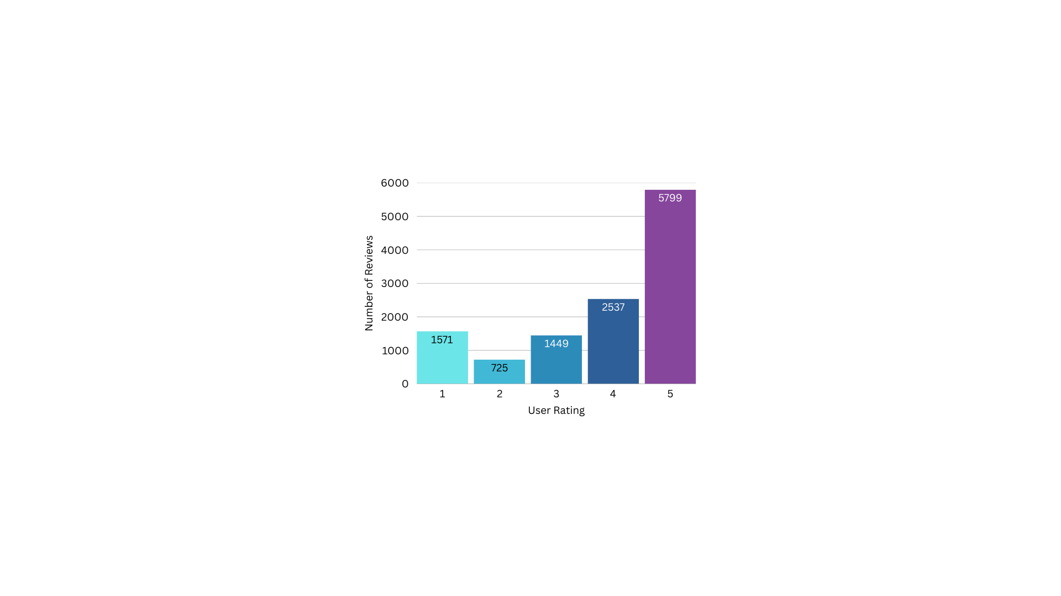
Nextdoor’s User Scores. User Ratings from last 5 years, United States (National)
Overall Rating: 1.2
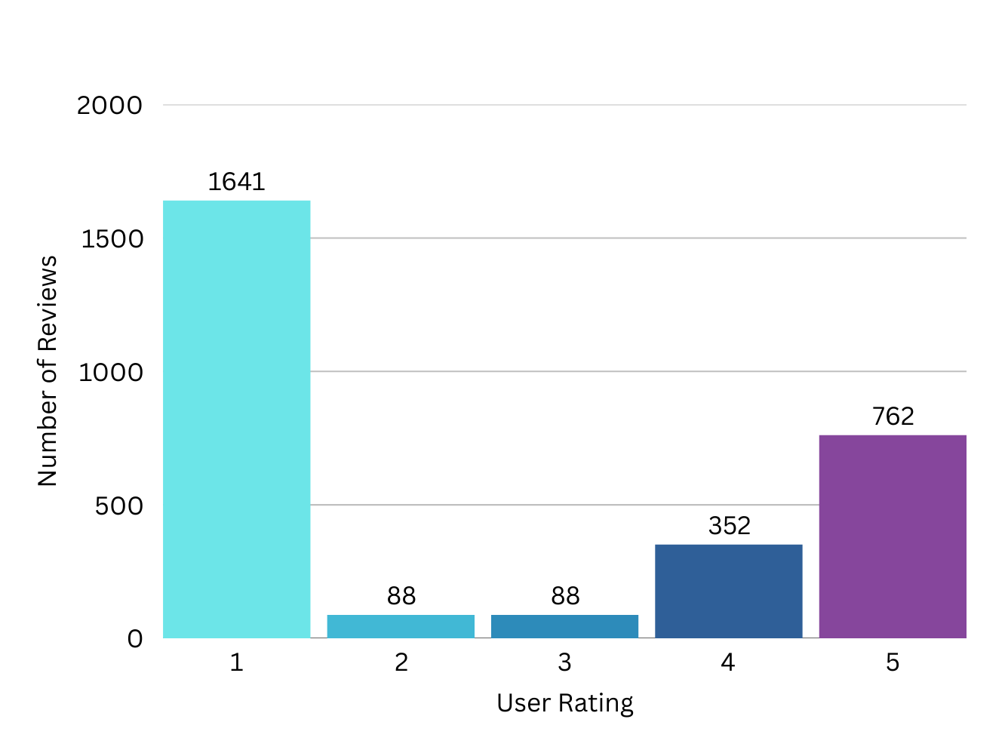
Opportunity Assessment:
SWOT Analysis:

STRENGTHS | WEAKNESSES
- Map Visualization  - Localized Focus  - Building community | - Getting users to switch to us  - Limited reach  - Moderation challenges
OPPORTUNITIES | THREATS
- Local business connections  - Event promotion  - In-App shop feature | - Competitors  - Privacy concerns  - Safety concerns

A few strengths of our app are a map visualization, localized focus, and a way to build a stronger community. When using the app, there will be a map displaying your current location and where you are at. Around you on the map will be pins placed by people who have reported or announced something in that spot. This allows for a more interactive and interesting way of being able to show what is happening around the local area. Another strength is the localized focus of the app. Being able to limit yourselves to your own local communities will allow for better engagement and trust, as interacting with likely familiar faces is more comfortable to most people. As for building a stronger community, this ties back into the localization point. Since there is a bigger focus for the local aspects of the app, it will ensure that a community will be built up overtime the more the app is used.
For the weaknesses, a significant challenge that we will have to face is trying to convince users to switch to our app. People tend to stay on the current existing local communications apps because the app that they are already using does what they need. So, without a proper way to distinguish ourselves from our competitors, there would be no reason for people to swap from the current existing local communication apps to ours. Next is the limited reach the app will have. The app being targeted towards local communications means that the outreach of the app won’t be as useful outside of that local area and the growth of the app could also be limited because of it. Lastly, freedom of expression will pose a key challenge in balancing users' desires to post and maintain a safe environment, while not being too restrictive at the same time. Other current local communications apps already struggle to moderate their own apps, which proves that it will be difficult for us too. It requires a good bit of effort to be able to allow free expression for all our users, while keeping proper moderation in place to ensure that our app stays inviting to use.
There are a multitude of opportunities for our app, such as local business connections, event promotions, and other features for the app. Having local business connections for our app will not only make it easier for users to find the local business, but also promotes that business to more people. This can lead to possible collaboration efforts to create better engagement for them and the community. Similarly with the previous point, having event promotions for our app will make it easier for users to find that specific event, promote it to a bigger outreach of people, and even have potential collaboration with the events. Lastly, we have thought about the possibility of adding a shop section for the app where you can do your in-app purchases for profile cosmetics. These purchasable profile cosmetics can add extra flair to your profile and customize it to your liking if the free options aren’t enough, offer limited time seasonal cosmetics, and other shop items to create more investment into the app.
Finally, the threats to our app include competitors, privacy, and safety concerns. The main competitors to our app will be Meetup and Nextdoor. These apps are a dominant force in this space, as they are already so well established in the market, which will make it difficult to compete against them. Privacy is also another threat that we have to address, since handling it improperly will lead to a variety of severe problems, ranging from legal issues to exposing sensitive information of our users. This leads to the next threat, safety. Without taking the proper measures to ensure the user’s safety as much as possible, they could fall for scams, or worse, be put in danger. So, similar to the previous point, it needs to be handled properly in order to ensure that all our users stay safe from malicious actors.
Gap Analysis:
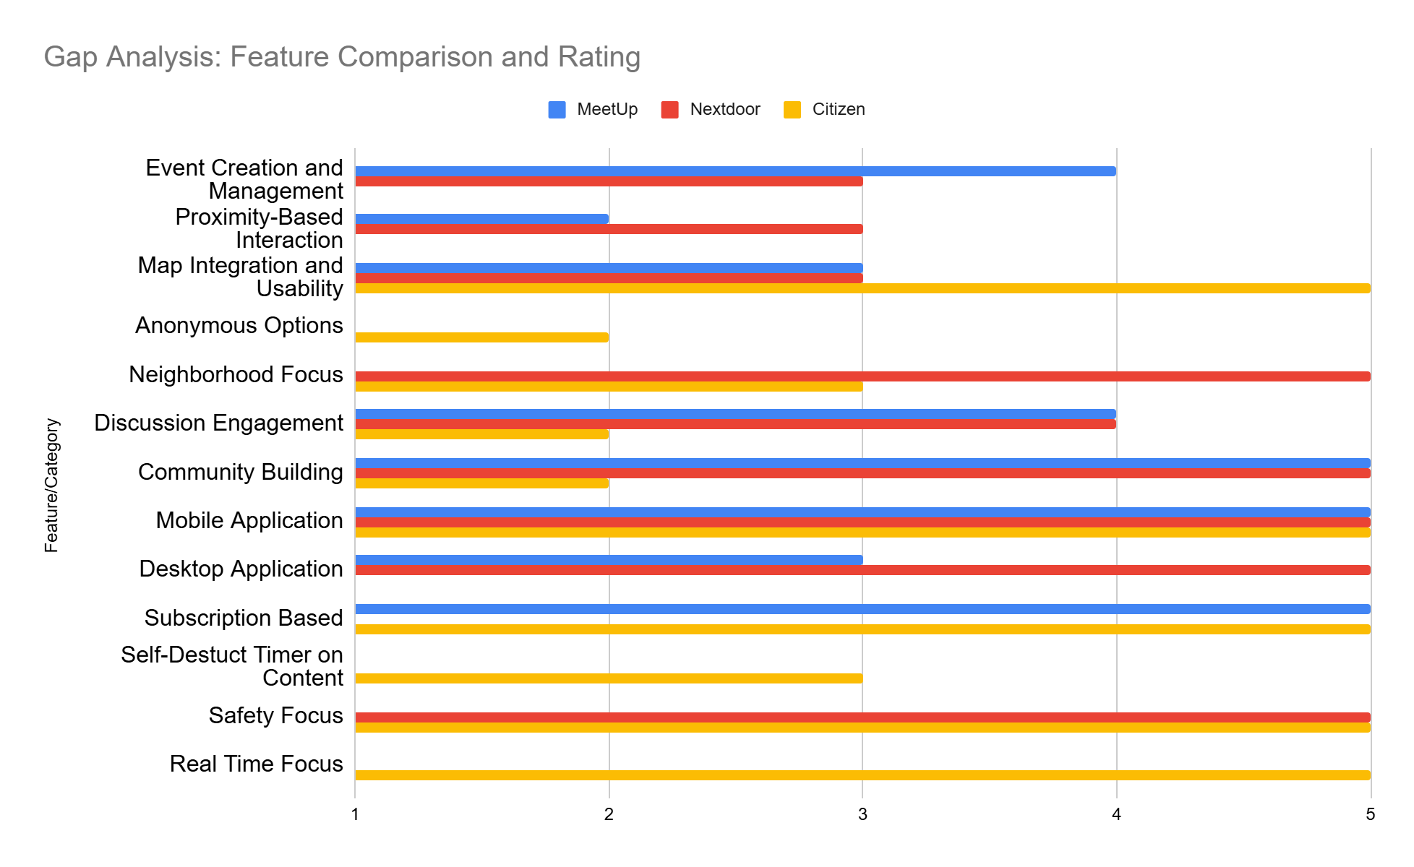
Strategic Positioning:
Differentiation:
Compared to our competitors, our app differentiates from the established apps by promoting organic conversations between locals. Although other apps do offer a degree of social features that allow users to talk and socialize with one another, they lack the function that allow users to actually meet up and hang out. This aspect is sorely needed with the disappearance of third-spaces, people are socializing in-person less and less. This is what will make The Bulletin different from what our competitors can offer.
What makes The Bulletin unique, is that it's based around creating a feed that is more personalized to a user’s local area. It would rely less on algorithms that optimize the content,
and be more focused on users organically producing the content. We will facilitate this by implementing a real-time chat function. This feature will allow users to talk to one another in real-time without having to make a post and wait for replies. It will allow quick and casual conversations among users in an area, allowing them to create and view content organically without having to sift through an algorithm or some “best posts” to get to them. One potential idea for the chat function is that we can implement temporary screen names which refresh after a certain time period, such as a week. This way, users that host or attend events can’t have their identities figured out without their consent, thus giving them an extra layer of anonymity that would be necessary for a platform such as The Bulletin. Another core feature of The Bulletin will be its visual map that users can post pins on--creating events that other users can view and even attend. With this feature, users can simply look on a map and see what pins are nearby and can immediately know where these events are and how far away they are without having to jump through hoops to find an address and putting it into a navigation app just to figure out it was too far away for them to want to go to it. An additional feature for the pins is that they only last for a few days and aren’t meant to be permanent mainstays, thus clearing the map of clutter and allowing other people to make their own pins while also limiting the amount of time that information to events is available, increasing user privacy of the event hosters.
Many of our competitors have similar features and functions to one another, but none of them will have the same comprehensive social aspect that The Bulletin will. By building The Bulletin around these features, we will differentiate it from our competition and it will create a platform that fits into a gap in the market that has thus far been left unfilled.
Differentiation Matrix:
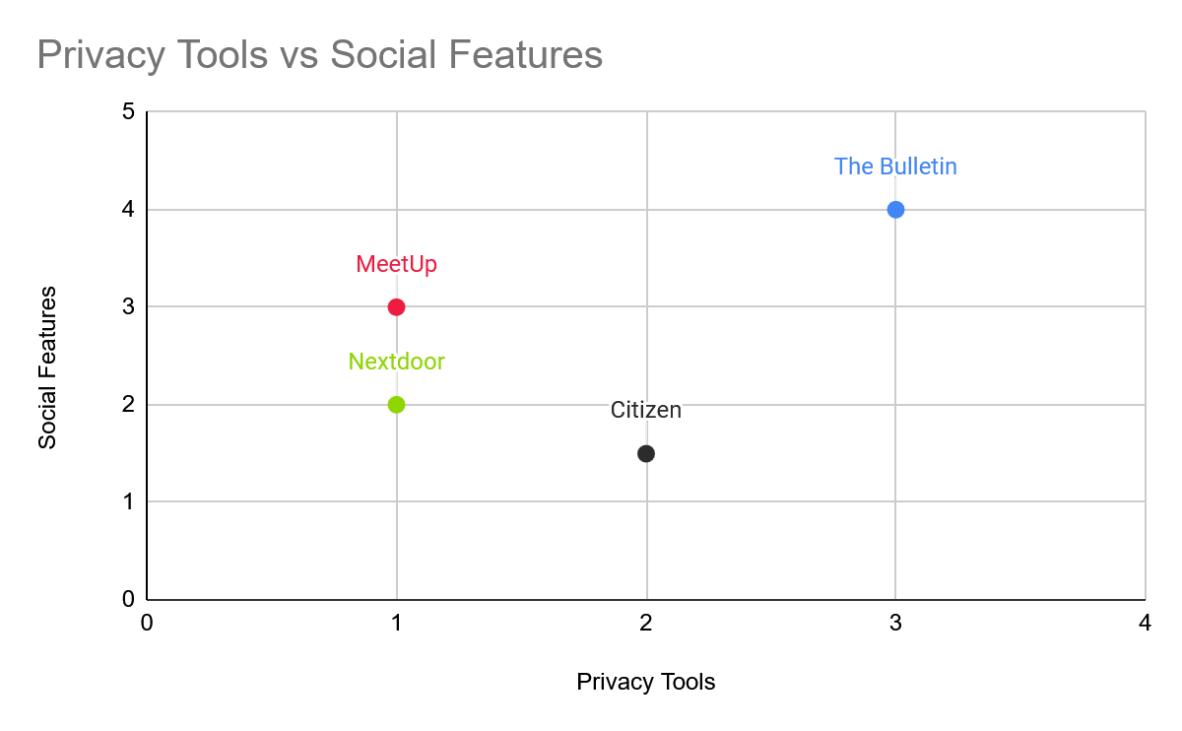
Potential Challenges:
First and foremost, a major concern that we found during our interview stage was privacy and security. The idea of meeting people through the internet and going to events with said people can be unnerving, especially considering you don’t know what they’re actually like. Furthermore, within the online platform itself, you can run the risk of chats being leaked, or identities and locations being doxxed--additional concerns from our interviewees. Interviewees also stressed their dislike of the collection and sale of their personal user data on other social media platforms. Another challenge would be monetization. As much as we would like to have The Bulletin be completely free from a user perspective, it’s just not realistic with running a server (or multiple) and any API costs we may accrue. Furthermore, having financial gain from the platform can help us potentially expand the scope and features of The Bulletin, but that’s for down the line.
To tackle the issue of event safety, we can implement ways to gauge how many people would be attending an event, such as through an RSVP system or a way to show how many likes are on a post which would show users’ interest. This way, users can feel safe knowing that an event will have a lot of attendees. For ensuring the safety of our users’ identities, we can implement end-to-end encryption so that chats cannot be leaked via external hacking. Furthermore, we can have users’ locations be recorded as being from a broad area, rather than one specific location (e.g. being somewhere in a certain ZIP code versus being at an address) so that neither hackers nor other users can track any individual user down. In the area of data privacy, we can implement account settings that allow users to control what information is being collected and how they can be used so that users can have confidence that their data is not being collected and sold against their consent. Much like other “free” platforms, we can implement certain paid features in order to make money to keep The Bulletin running. Some interviewees stated that they didn’t mind premium features as long as the core features were accessible and usable. In addition, they didn’t mind paying for the premium as long as the benefits outweighed the costs. One method is that we can implement unobtrusive advertisements, similar to older web pages that have ads built in and not as a pop-up or an unskippable 30 second video as with some streaming websites. Another would be to have premium features that enhance the core features of The Bulletin. For instance, users could pay a monthly fee to be able to view a bigger map and have the ability to post more pins compared to free users. These are just a few strategies that we can undertake to mitigate what are going to be the biggest challenges in creating The Bulletin as we go forward.
Conclusion:
Summarization:
Our market analysis has shown a demonstrable gap within the local interaction space. Current competitors focus on already defined groups, fail to take advantage of the increased availability of user geolocation data, or are limited in the space you can interact in. Meetup and other social media platforms require already being acquainted with a group before finding content relating to your location. Nextdoor and Ring are limited within reach to one’s neighborhood and thus shrinking the space people can interact with.
We wish to fill the gap by helping users interact with those nearby beyond one’s neighborhood while staying local by assigning posts and public events to pins on a map, and to dynamically change the users’ visibility and/or interactivity with pins depending on geolocation. By displaying content on a map, users will have a streamlined experience checking up around them at a moment's notice anywhere in the world. To ensure sustainability of The Bulletin and its users, we need to explore ways to achieve funding from user customization or partnerships, keep users' information secure (location approximation, anonymization, encryption), and provide tools like event interest to inform users in an honest fashion.
Implications:
Based on our market research, it is implying that we need to make sure to address what people are looking for most from local communication apps. We have to include local integration, user privacy, and community in order to compete with the top apps. Without addressing these key market shifts and trends, we won’t be able to have a chance at competing in the market.
As for our next steps, we will need to ensure that privacy will not be violated to build trust with our users. This is probably the most important finding from our market research, as this seems to be a common trend for all of the apps in the local communications market. People do not want information about them to not be secured or private when in the hands of these companies. Then, we will have to focus on how we can do local integration within our app, which will also lead to improving the community aspect of it. Since we want to compete in the market of local communications apps, this is essential in order for us to go against our competitors. Without coming up with some ways to do this, long term success will be difficult for our app.
Appendices:
Competitor Features:
Application Features | Meetup | Nextdoor | Citizen | Eventbrite | Snapchat
Location-Based Events | ✅ | ❓ | ❓ | ✅ | ❓
User Events | ✅ | ✅ | ⛔ | ✅ | ✅
Visual Map Feature | ⛔ | ❓ | ✅ | ✅ | ✅
Anonymous Options | ⛔ | ⛔ | ❓ | ⛔ | ❓
Local Chat | ✅ | ⛔ | ⛔ | ⛔ | ⛔
Image Sharing | ✅ | ✅ | ✅ | ⛔ | ✅
Mobile Application | ✅ | ✅ | ✅ | ✅ | ✅
Verification | ✅ | ✅ | ✅ | ✅ | ✅
Self-Destruct Messages | ⛔ | ⛔ | ✅ | ❓ | ✅

Meetup Reviews:
Meetup has lots of mixed reviews and ratings, but the majority of the ratings are between 4 and 5 stars (66% of ratings were 4 stars and above). Users who rated 4 stars and above appreciated community engagement and saw recent improvements within the new API features that allowed translation. Those who rated 3 stars gave it a satisfactory review while those who rated below a 2 reported that the app glitched, had log-in issues, difficulty navigating the interface, and concerns over the app becoming heavily commercialized, as well as privacy concerns. Some suggestions that the reviewers had were for the app to address the app’s glitches, technical bugs, and improve the privacy controls and permissions. Additionally, a user mentioned that the app had charged their account a day earlier than expected after a free trial. They stated “I recently signed up for a one-week trial period, however, to my surprise, on the third day of the trial, I discovered that Meetup had charged me an unauthorized amount of $500! I am now faced with the frustrating task of pursuing a refund from their customer support team. I hope that Meetup will address this issue promptly and efficiently, as this experience has left me disappointed in their service.”
Nextdoor Reviews:
Similarly, Nextdoor has lots of mixed reviews, although a majority are 2 stars and lower (55.19% of ratings are 2 stars and below). While users who rated 4 stars and above found the app to have an easy setup process and nice interface, many of the other reviewers found several flaws. Other users who rated 2 stars and below found that the Search and Event pages were often useless, there were privacy concerns over excessive data collection, and moderation over content was a concern as well. Additionally, many users found it hard to get rid of the app and their information within it. They found that they would get continuous emails long after they had deleted their account. For example, a user stated, “Don't sign up!!! The emails you get are absolutely and utterly ridiculous and they make it impossible to unsubscribe. I'm talking several times a day, every day, AFTER I tried to unsubscribe from the hundreds of categories of ‘notifications’”. Meanwhile, some improvements that users suggested were for the Search bar to have better functionality and for privacy concerns to be addressed.

Citations:
“Can Eventbrite’s Growing Ticket Volume Offset Its Widening Losses? Q4 Earnings Analysis.” Eventbrite Q4 Earnings: Revenue Hits $76.5M Despite 13% YoY Decline, Ticket Volume Grows | EB Stock News, StockTitan, 27 Feb. 2025, www.stocktitan.net/news/EB/eventbrite-reports-fourth-quarter-2024-financial-vu47has5pne1.html#:~:text=Eventbrite%20(NYSE%3A%20EB)%20reported,million%20loss%20in%20Q4%202023.
Dkramer@nextdoor.com. “Nextdoor Reports Fourth Quarter and Full Year 2024 Results.” About Nextdoor, 27 Feb. 2025, about.nextdoor.com/press-releases/nextdoor-reports-fourth-quarter-and-full-year-2024-results/.
“Meetup Revenue: Annual, Quarterly, and Historic.” Zippia, 21 July 2023, www.zippia.com/meetup-careers-74297/revenue/#.
“Report: Citizen Business Breakdown & Founding Story: Contrary Research.” Report: Citizen Business Breakdown & Founding Story | Contrary Research, research.contrary.com/company/citizen. Accessed 28 Mar. 2025.
“Snap Inc.. Announces Fourth Quarter and Full Year 2024 Financial Results.” Snap Inc. - Snap Inc. Announces Fourth Quarter and Full Year 2024 Financial Results, investor.snap.com/news/news-details/2025/Snap-Inc.-Announces-Fourth-Quarter-and-Full-Year-2024-Financial-Results/default.aspx. Accessed 28 Mar. 2025.
“US - Nextdoor Is Rated ‘Bad’ with 1.2 / 5 on Trustpilot.” Trustpilot, www.trustpilot.com/review/nextdoor.com. Accessed 29 Mar. 2025.
“UK - Nextdoor Is Rated ‘Poor’ with 2.7 / 5 on Trustpilot.” Trustpilot, www.trustpilot.com/review/nextdoor.co.uk. Accessed 29 Mar. 2025.

Back up V2 Revision Stage
[NOT FINAL - THIS TAB IS JUST SO WE CAN READ IT EASIER!!!]
Group 6: Team Pinpoint
Andy Hoang, Citlally Vasquez, Darrel Dennis, Max Ju, Troy Waters, Wai Soltow
Milestone 3 Written Report
Introduction:
Recap:
Our initial concept was to create a local focused social media program where people can post freely about anything, where visibility of posts are tied directly to the closeness to the user. This initial concept was rooted in the belief that hyper-localized content could foster stronger community connections and make it easier for users to discover events and interact with their local community. We prioritized proximity, ensuring that users would see posts relevant to their local surroundings. That initial conception guided our questions and interviewing process.
From the user-centered design research we refined the project idea to as follows. The app will contain 3 main pages the user can select from. The “Board” page, the Map page, and the Chat page. The app’s main screen is an “infinite feed” of unique Pins where users may continue scrolling to see Pins posted by others sorted by distance. Inspired by forums much more common in the earlier days of the Internet, our Pins functions similar to a typical internet forum’s thread system. Pins may include an image or no image, and a necessary text submission alongside it. If a Pin interests a user, they may click on the Pin to open up that Pin page which may include more details about the event, as well as replies.
The Map section of the app will include a standard Mercator projection map where users may interactively see what Pins are close to them. This includes zooming in and out, pressing on Pins, and viewing. The entire map of the world will be present, but the pins that are visible will still be constrained to a local area. Users may not see Pins that are too far away from their current location.
Lastly, we have a Chat page. In this page there will be a free flowing chat where message visibility is constrained by how close messages are to the user’s current location. Users may send out messages into the chat, and only those within the users’ radius may see those messages.
Significance of Market Research:
The market research conducted through 17 interviews was instrumental in shaping the direction of the project. From the pain points and concerns, we are able to get a better idea of what users can get out of our app. Through our user interviews and analysis, we identified pain points in communication, such as over-reliance of word of mouth, fragmented small group communities, and lack of intuitive tools for event discovery. In addition to those pain points, we identified the following concerns. Interviewees had concerns over location tracking, data sharing and selling, event legitimacy, and content moderation.
Over-Reliance on Word of Mouth was cited as an issue for interviewees. This pain point legitimized the need for an easy place to post local event information without the stress of being seen worldwide. Our platform serves as a centralized place to post and discover local events. Allowing users to easily create Pins with images and supplemental text, this affords users great freedom in how they want to express themselves with their local community.
Small group communities are fragmented. Interviewees spoke about how they might be a part of many regular groups but must keep track of several different events through different means. This concern informed our design by being a single unified space for seeing local events.
Lack of Intuitive Tools for Event Discovery was a commonality between participants in our market research. Our answer to this pain point was to create a map of pins. This map tool affords the user intuitive event discovery. In addition to our map tool, sorting by distance in the Board section helps alleviate some of the analysis paralysis that comes with discovering the events in a locality.
Interviewees also spoke on Concerns Over Event Legitimacy. Our approach to this problem is two fold. We intend to combat this issue by requiring users to sign up with phone number verification. This ensures that events are posted by real people, and adversarial attacks against the system are much harder to scale. In addition to phone number verification, we also intend to add event attendance tracking to allow users to gauge event interest.
Lastly, interviewees had Concerns Over Content Moderation. This insight helped guide us towards a 3 pronged approach. First, users may report harmful posts which will be reviewed by moderators. Secondly, we intend to add automated content filters to block obviously harmful content and spam. Lastly, we intend to add Clear Community Guidelines to help users reference what is allowed content on the app.
These pain points and concerns guided us to address what users truly need to enhance the local interaction space. By tackling issues such as fragmented communication, lacking event visibility, event legitimacy, and content moderation, we’ve designed a solution that will provide value to users in discovering local happenings and events. The insights over concerns with the app concept have been invaluable to the current design and what problems need to be addressed before shipping the application out into the world. Moving forward, these discoveries will serve as a foundation for our project as we continually iterate this project. Our refined solution will bridge the gap between the current state of local communication.
Market Overview:
Market Size and Growth Trend:
Some competitors that more closely compete in the local event sphere are private and thus will be difficult to ascertain metrics on. In light of that, some general purpose social media apps are included to demonstrate general market size and growth trends.
The graph above displays a straight best fit line over the logarithmic revenues for each company in the list. In a logarithmic graph, that a straight best fit line indicates exponential growth for all of the companies listed.
In this graph of Year over Year % change, we can see that Facebook, Snapchat, and Nextdoor have a convex upward curve best fit line. This indicates that these company’s growth is increasing, but the rate of growth is decreasing, meaning they are reaching market saturation. Eventbrite has a concave down and decreasing best fit line. This indicates that losses are worsening and an increasing rate overtime.
Major Players and Market Share:
General Observations:
The market for local communications apps is difficult to determine, as specific data on these apps are limited. This type of app is essentially a subset of the various communications apps such as Nexdoor, Citizen, or Meetup, which means that whatever happens in those markets there, will also likely affect the market for the local communications apps.
During our research into the local communications app niche, we discovered the combined market capitalization for the 3 largest apps totals to about $310 million USD (Nextdoor, Citizen, and Meetup). Nextdoor was the largest of the 3, valuing at around $247 million, which is almost 80% of the local communications market. Their value was a sizable increase from the last year, with a 13% increased revenue from the previous year. As for Citizen, it was valued at an estimated $35 million, and for Meetup, it was valued at about $28 million.
Currently, the market for global and local social networking, instant messaging, and mobile messaging apps all show a promising future for this market. As of right now, the market for all of these apps are valued at billions of dollars in total. Not only that, they are also showing no signs of slowing down in the future either. This is because of a combination of multiple factors; people wanting local integration, user privacy, and community.
Direct Competitor Analysis:
Application Features | Meetup | Nextdoor | Citizen
Location-Based Events | ✅ Yes | ❓Just post, not events | ❓Only for Emergencies
User Events | ✅Yes | ✅Yes | ⛔Only Crime Reports
Visual Map Feature | ⛔No | ❓Only Lost and Found | ✅Yes, for current incidents.
Anonymous Options | ⛔No | ⛔No | ❓Partially, only alerts
Local Chat | ✅Yes | ⛔No, Voting only | ⛔No
Image Sharing | ✅Yes, for Event | ✅Yes | ✅Yes
Mobile Application | ✅Yes | ✅Yes | ✅Yes
Verification | ✅Organizer Discretion | ✅Real Name and Address | ✅Verifying Reports
Self-Destruct Messages | ⛔No | ⛔No | ✅Yes, alerts fade.

It should be mentioned that Citizen isn’t so much a direct competitor, but more so the only other popular application for local communication. It comes with great surprise in such a short timeframe we found ourselves pulling for scraps. A lot of other competitors are more indirect: such as Facebook Groups or Telegram groups. To develop a full table of features against competitors who satisfy strictly the requirement of local communication is difficult to come by. Since applications tend to provide very broad tools, what defines a potential competitor is actually a very difficult question to answer.
Competitor Analysis 1 - Meetup:
Overview: Brief Introduction of Meetup
In 2002, a new website showed face on the internet to streamline the ever increasing connectedness of locals in their respective neighborhoods. At the time it was quite remarkable - smartphones wouldn’t be released for another 5 years and the word ‘app’ wasn’t part of everyday language. Instead of phone dialing all your neighbors and getting stuck in an undesired conversation for hours on end, you could simply plan an event on their website. Anyone could register and the service was free. Fast forward to today and now we have the mobile application. Join a local group, join the group's event, and meetup. However, unlike the original 2002 Meetup, current market Meetup comes with a lot more nuances which affect everything: from market growth to user experience, and to insights regarding the overall market of local citizen communication tools.
First Impressions: “Pay me $2.99 for a First Impression”
While first impressions can prove to be extremely insightful in the nature of what an application is, presenting this image of subscription fees will largely carry this first impression. For context, the option “Try for $2.99/month” and “Try for Free” both lead to the same page. Before we have seen the application the user is presented with the illusion of choice and is required to give their credit card information. From a security standpoint this makes a lot of sense. Telegram and Discord both have automated bot problems since accounts are free. However, the user hasn’t even seen the application yet! What does the user interface look like? How does it work? What does the application look like in action? Most individuals are well aware of the fact that companies exploit user forgetfulness to unsubscribe before the next billing statement. Needlessly to say, but users have to pay money for a first impression.
Usability and user experience insights
Before a user can even browse, they must join a group. All events are tied directly to a group. To begin browsing, it’s ideal then to simply join as many groups as possible, as nearly all posts require being in the group to see. Meetup works in a more classic manner in simply giving users the address of the event, but no visual map indicating where the event might be. This can be quite problematic when planning events at parks where you may give out the address of the parking lot, but not the actual reserved location for the event. But overall the application is straight forward: plan an event, drop the address to everyone in the group, and off they go.
Taking our first step into the reviews on the Meetup app, we are immediately bombarded with feedback. Users can’t login with their Google account, the application freezes, and trying to make a new account results in “an account already exists for that.” Should a user get past this bumpy start there’s the fact the application requires permissions. But apparently giving the Meetup application full permission to use a phone's built-in Calendar system doesn’t work. So does Meetup require even more permissions just to add events to the user calendar? There is no further clarification as to why such a simple feature doesn’t work. So, let’s take a moment to zoom out from the swamp of complaints on basic features not working and discuss money.
Money may make the world go around, but money verifies you’re real on Meetup. The topic of verification has been brought up extensively: whether it’s by 2-factor authentication, age verification through a government tool, or moderator approval by sending pictures of your driver's license. With money on Meetup you get higher priority in waitlists. You want to be able to send multiple messages to a friend in a single day? Money will let a user do that. Want to check who is going to the event? That last question requires breaking professionalism for a moment. Having to spend money to find out who's attending your own event is atrocious and highly suspicious. If a user can’t obtain even the most basic information on who's attending an event, then that’s simply exploiting the user's ignorance. This design philosophy borders on exploitation, since paying for basic information is a major ethical and accessibility concern.
Standout features or notable gaps
Observation of past overwhelming user frustrations isn’t without merit. As one might guess, Meetup is a competitor from a technical perspective. In fact, Meetup’s last popularity spike was in 2012. Finding standout features on Meetup proved difficult because the market has drastically changed in the last 10 years. Perhaps in 2012 it proved to be the best solution. But now it pales in comparison to other companies who give tools exponentially more powerful - and without the paywall. When Nextdoor (the next competitor) and Meetup are removed from the equation, we get a surprising result: nothing. But nothing means there’s a gap in the market. During the team’s presentation it was discussed how there’s an oversaturation in the market. This is primarily the result of indirect competitors who may not specialize in local communication, but have tools that just happen to facilitate it. Tools for specialized local event planning simply don’t exist on a large scale, but perhaps it’s time for that change.
User Reviews & Ratings
(Below) Meetup: Average Review Scores Yearly. All countries.

Meetup’s App User Scores. User Ratings from Last 5 Years, All Countries
Meetup’s App User Scores. Last 5 years. United States only.
Competitor Analysis 2 - Nextdoor:
Overview: Brief Introduction of Nextdoor
Nextdoor was first created in 2011 with the intention of allowing neighbors to privately communicate with each other through a social platform, similar to Facebook and Instagram, which were on the rise at that time. At the time, with the rise of other social media platforms such as Facebook and Instagram, locals were looking for a similar platform that would allow them to communicate with others nearby and through that came “Nextdoor”. The website/app is a local, neighborhood app specialized in providing a private social network for residents to connect, share local information, and build community.
Features and Offerings
In the past decade, the website/app has gained lots of features within the app such as public group chats, ability to discover local businesses, meet others with similar interests, discover what events are happening in the area, and private “street” group chats. Within these street group chats, only verified residents within a block can enter the chat and interact with others. In these chats, locals can ask questions, share updates, buy, sell, or borrow items. Additionally, users can block each other, create posts similar to Instagram, and also see what topics/posts are trending in the app.
Hands-on Evaluation and First Impression
Upon further inspection, from the moment a user opens the site, it prompts the user with a simple “Log-in” or “Register” page. Once the user registers, a series of questions are asked such as “What’s your address?” or “What groups are you interested in?”. After an account is established, the site seems pretty easy to navigate. The menu/navigation bar showcases options such as Home, For Sale & Free, Chats, Notifications, Groups, Events, Invite Neighborhoods, and Post. There are also buttons that allow the user to view all posts that are Recent, Nearby, or Trending. As the user scrolls through their feed, they can view all sorts of posts ranging from people offering services, asking for recommendations, updating others on city events, complaining about loud vehicles, telling stories, asking for help when moving items, and a frequent topic was (lost or found) animals. In between posts, there are also lots of advertisements from local and non-local companies. Most mentioned services for remodeling or discounts/deals for department stores. Furthermore, the user can view all of their posts within their Profile section, and they can also earn rewards for making frequent posts that fall under that category, although there are no clear instructions on how to earn them. Some awards were “Biz Supporter, Convo Starter, Party Planner, and Visual Artist”. All in all, the usability of the website seems very user-friendly and the navigation bar simplifies things by a lot. There you can access all features, the Post button is a bright green color, and you can explore other neighborhoods. Also within the groups section, people can easily create their own groups about any topic. Furthermore, most of the advertisements were related to home renovation and services for maintenance, but there were occasionally some irrelevant advertisements that mentioned webinars and other random services.
Stand Out Features
Additionally, there was an “Events” feature that stood out. Within this section, there were some local events such as “Jigsaw puzzle swap/exchange” but there were also a lot that were random such as “Don’t let market volatility destroy your retirement”. Other events looked like they were clearly placed by businesses such as “Bites and Brews Happy Hour at ISM Brewing in Long Beach”. While it is beneficial for businesses to advertise themselves within the events section, it does not show a true representation of what the community is interested in. If a user were to propose meeting up at a business and hanging out there, it would show initiative to hang out rather than a business planting an event. Similarly, most of these events looked like they were also placed by traveling entertainers or other cities, with the exception of 2 actual local events. This sentiment applies to posts as well. While there were locals posting about their regular day, there were a lot of posts that just revolved around services. The posts related to services paired with business advertisements gives the feeling that the user is on some sort of marketplace rather than a neighborhood app that is founded on connecting with others in the area.
User Reviews and Ratings
Nextdoor’s User Scores. User Ratings from last 5 years, United Kingdom
(International)
Overall Rating: 2.7
Nextdoor’s User Scores. User Ratings from last 5 years, United States (National)
Overall Rating: 1.2
Opportunity Assessment:
SWOT Analysis:

STRENGTHS | WEAKNESSES
- Map Visualization  - Localized Focus  - Building community | - Getting users to switch to us  - Limited reach  - Moderation challenges
OPPORTUNITIES | THREATS
- Local business connections  - Event promotion  - In-App shop feature | - Competitors  - Privacy concerns  - Safety concerns

A few strengths of our app are a map visualization, localized focus, and a way to build a stronger community. When using the app, there will be a map displaying your current location and where you are at. Around you on the map will be pins placed by people who have reported or announced something in that spot. This allows for a more interactive and interesting way of being able to show what is happening around the local area. Another strength is the localized focus of the app. Being able to limit yourselves to your own local communities will allow for better engagement and trust, as interacting with likely familiar faces is more comfortable to most people. As for building a stronger community, this ties back into the localization point. Since there is a bigger focus for the local aspects of the app, it will ensure that a community will be built up overtime the more the app is used.
For the weaknesses, a significant challenge that we will have to face is trying to convince users to switch to our app. People tend to stay on the current existing local communications apps because the app that they are already using does what they need. So, without a proper way to distinguish ourselves from our competitors, there would be no reason for people to swap from the current existing local communication apps to ours. Next is the limited reach the app will have. The app being targeted towards local communications means that the outreach of the app won’t be as useful outside of that local area and the growth of the app could also be limited because of it. Lastly, freedom of expression will pose a key challenge in balancing users' desires to post and maintain a safe environment, while not being too restrictive at the same time. Other current local communications apps already struggle to moderate their own apps, which proves that it will be difficult for us too. It requires a good bit of effort to be able to allow free expression for all our users, while keeping proper moderation in place to ensure that our app stays inviting to use.
There are a multitude of opportunities for our app, such as local business connections, event promotions, and other features for the app. Having local business connections for our app will not only make it easier for users to find the local business, but also promotes that business to more people. This can lead to possible collaboration efforts to create better engagement for them and the community. Similarly with the previous point, having event promotions for our app will make it easier for users to find that specific event, promote it to a bigger outreach of people, and even have potential collaboration with the events. Lastly, we have thought about the possibility of adding a shop section for the app where you can do your in-app purchases for profile cosmetics. These purchasable profile cosmetics can add extra flair to your profile and customize it to your liking if the free options aren’t enough, offer limited time seasonal cosmetics, and other shop items to create more investment into the app.
Finally, the threats to our app include competitors, privacy, and safety concerns. The main competitors to our app will be Meetup and Nextdoor. These apps are a dominant force in this space, as they are already so well established in the market, which will make it difficult to compete against them. Privacy is also another threat that we have to address, since handling it improperly will lead to a variety of severe problems, ranging from legal issues to exposing sensitive information of our users. This leads to the next threat, safety. Without taking the proper measures to ensure the user’s safety as much as possible, they could fall for scams, or worse, be put in danger. So, similar to the previous point, it needs to be handled properly in order to ensure that all our users stay safe from malicious actors.
Gap Analysis:
Strategic Positioning:
Differentiation:
Compared to our competitors, our app differentiates from the established apps by promoting organic conversations between locals. Although other apps do offer a degree of social features that allow users to talk and socialize with one another, they lack the function that allow users to actually meet up and hang out. This aspect is sorely needed with the disappearance of third-spaces, people are socializing in-person less and less. This is what will make The Bulletin different from what our competitors can offer.
What makes The Bulletin unique, is that it's based around creating a feed that is more personalized to a user’s local area. It would rely less on algorithms that optimize the content,
and be more focused on users organically producing the content. We will facilitate this
One core differentiating feature that we plan to implement is a real-time chat function. This feature will allow users to talk to one another in real-time without having to make a post and wait for replies. This function will best be used to quickly and immediately talk to the people around you, such as sharing information and discussing recent events, and will facilitate quick and casual conversations among users in an area.
One potential idea for the chat function is that we can implement temporary screen names which refresh after a certain time period, such as a week. This way, users that host or attend events can’t have their identities figured out without their consent, thus giving them an extra layer of anonymity that would be necessary for a platform such as The Bulletin. Another core feature of The Bulletin will be its visual map that users can post pins on--creating events that other users can view and even attend. With this feature, users can simply look on a map and see what pins are nearby and can immediately know where these events are and how far away they are without having to jump through hoops to find an address and putting it into a navigation app just to figure out it was too far away for them to want to go to it. An additional feature for the pins is that they only last for a few days and aren’t meant to be permanent mainstays, thus clearing the map of clutter and allowing other people to make their own pins while also limiting the amount of time that information to events is available, increasing user privacy of the event hosters.
Many of our competitors have similar features and functions to one another, but none of them will have the same comprehensive social aspect that The Bulletin will. By building The Bulletin around these features, we will differentiate it from our competition and it will create a platform that fits into a gap in the market that has thus far been left unfilled.
Differentiation Matrix:
Potential Challenges:
First and foremost, a major concern that we found during our interview stage was privacy and security. The idea of meeting people through the internet and going to events with said people can be unnerving, especially considering you don’t know what they’re actually like. Furthermore, within the online platform itself, you can run the risk of chats being leaked, or identities and locations being doxxed--additional concerns from our interviewees. Interviewees also stressed their dislike of the collection and sale of their personal user data on other social media platforms. Another challenge would be monetization. As much as we would like to have The Bulletin be completely free from a user perspective, it’s just not realistic with running a server (or multiple) and any API costs we may accrue. Furthermore, having financial gain from the platform can help us potentially expand the scope and features of The Bulletin, but that’s for down the line.
To tackle the issue of event safety, we can implement ways to gauge how many people would be attending an event, such as through an RSVP system or a way to show how many likes are on a post which would show users’ interest. This way, users can feel safe knowing that an event will have a lot of attendees. For ensuring the safety of our users’ identities, we can implement end-to-end encryption so that chats cannot be leaked via external hacking. Furthermore, we can have users’ locations be recorded as being from a broad area, rather than one specific location (e.g. being somewhere in a certain ZIP code versus being at an address) so that neither hackers nor other users can track any individual user down. In the area of data privacy, we can implement account settings that allow users to control what information is being collected and how they can be used so that users can have confidence that their data is not being collected and sold against their consent. Much like other “free” platforms, we can implement certain paid features in order to make money to keep The Bulletin running. Some
interviewees stated that they didn’t mind premium features as long as the core features were accessible and usable. In addition, they didn’t mind paying for the premium as long as the benefits outweighed the costs. One method is that we can implement unobtrusive advertisements, similar to older web pages that have ads built in and not as a pop-up or an unskippable 30 second video as with some streaming websites. Another would be to have premium features that enhance the core features of The Bulletin. For instance, users could pay a monthly fee to be able to view a bigger map and have the ability to post more pins compared to free users. These are just a few strategies that we can undertake to mitigate what are going to be the biggest challenges in creating The Bulletin as we go forward.

Conclusion:
Summarization:
Our market analysis has shown a demonstrable gap within the local interaction space. Current competitors focus on already defined groups, fail to take advantage of the increased availability of user geolocation data, or are limited in the space you can interact in. Meetup and other social media platforms require already being acquainted with a group before finding content relating to your location. Nextdoor and Ring are limited within reach to one’s neighborhood and thus shrinking the space people can interact with.
We wish to fill the gap by helping users interact with those nearby beyond one’s neighborhood while staying local by assigning posts and public events to pins on a map, and to dynamically change the users’ visibility and/or interactivity with pins depending on geolocation. By displaying content on a map, users will have a streamlined experience checking up around them at a moment's notice anywhere in the world. To ensure sustainability of The Bulletin and its users, we need to explore ways to achieve funding from user customization or partnerships, keep users' information secure (location approximation, anonymization, encryption), and provide tools like event interest to inform users in an honest fashion.
Implications:
Based on our market research, it is implying that we need to make sure to address what people are looking for most from local communication apps. We have to include local integration, user privacy, and community in order to compete with the top apps. Without addressing these key market shifts and trends, we won’t be able to have a chance at competing in the market.
As for our next steps, we will need to ensure that privacy will not be violated to build trust with our users. This is probably the most important finding from our market research, as this seems to be a common trend for all of the apps in the local communications market. People do not want information about them to not be secured or private when in the hands of these companies. Then, we will have to focus on how we can do local integration within our app, which will also lead to improving the community aspect of it. Since we want to compete in the market of local communications apps, this is essential in order for us to go against our competitors. Without coming up with some ways to do this, long term success will be difficult for our app.
Appendices:
Competitor Features:
Application Features | Meetup | Nextdoor | Citizen | Eventbrite | Snapchat
Location-Based Events | ✅ | ❓ | ❓ | ✅ | ❓
User Events | ✅ | ✅ | ⛔ | ✅ | ✅
Visual Map Feature | ⛔ | ❓ | ✅ | ✅ | ✅
Anonymous Options | ⛔ | ⛔ | ❓ | ⛔ | ❓
Local Chat | ✅ | ⛔ | ⛔ | ⛔ | ⛔
Image Sharing | ✅ | ✅ | ✅ | ⛔ | ✅
Mobile Application | ✅ | ✅ | ✅ | ✅ | ✅
Verification | ✅ | ✅ | ✅ | ✅ | ✅
Self-Destruct Messages | ⛔ | ⛔ | ✅ | ❓ | ✅

Meetup Reviews:
Meetup has lots of mixed reviews and ratings, but the majority of the ratings are between 4 and 5 stars (66% of ratings were 4 stars and above). Users who rated 4 stars and above appreciated community engagement and saw recent improvements within the new API features that allowed translation. Those who rated 3 stars gave it a satisfactory review while those who rated below a 2 reported that the app glitched, had log-in issues, difficulty navigating the interface, and concerns over the app becoming heavily commercialized, as well as privacy concerns. Some suggestions that the reviewers had were for the app to address the app’s glitches, technical bugs, and improve the privacy controls and permissions. Additionally, a user mentioned that the app had charged their account a day earlier than expected after a free trial. They stated “I recently signed up for a one-week trial period, however, to my surprise, on the third day of the trial, I discovered that Meetup had charged me an unauthorized amount of $500! I am now faced with the frustrating task of pursuing a refund from their customer support team. I hope that Meetup will address this issue promptly and efficiently, as this experience has left me disappointed in their service.”
Nextdoor Reviews:
Similarly, Nextdoor has lots of mixed reviews, although a majority are 2 stars and lower (55.19% of ratings are 2 stars and below). While users who rated 4 stars and above found the app to have an easy setup process and nice interface, many of the other reviewers found several flaws. Other users who rated 2 stars and below found that the Search and Event pages were often useless, there were privacy concerns over excessive data collection, and moderation over content was a concern as well. Additionally, many users found it hard to get rid of the app and their information within it. They found that they would get continuous emails long after they had deleted their account. For example, a user stated, “Don't sign up!!! The emails you get are absolutely and utterly ridiculous and they make it impossible to unsubscribe. I'm talking several times a day, every day, AFTER I tried to unsubscribe from the hundreds of categories of ‘notifications’”. Meanwhile, some improvements that users suggested were for the Search bar to have better functionality and for privacy concerns to be addressed.
Backup Data:

Citations:
“Can Eventbrite’s Growing Ticket Volume Offset Its Widening Losses? Q4 Earnings Analysis.” Eventbrite Q4 Earnings: Revenue Hits $76.5M Despite 13% YoY Decline, Ticket Volume Grows | EB Stock News, StockTitan, 27 Feb. 2025, www.stocktitan.net/news/EB/eventbrite-reports-fourth-quarter-2024-financial-vu47has5pne1.html#:~:text=Eventbrite%20(NYSE%3A%20EB)%20reported,million%20loss%20in%20Q4%202023.
Dkramer@nextdoor.com. “Nextdoor Reports Fourth Quarter and Full Year 2024 Results.” About Nextdoor, 27 Feb. 2025, about.nextdoor.com/press-releases/nextdoor-reports-fourth-quarter-and-full-year-2024-results/.
“Meetup Revenue: Annual, Quarterly, and Historic.” Zippia, 21 July 2023, www.zippia.com/meetup-careers-74297/revenue/#.
“Report: Citizen Business Breakdown & Founding Story: Contrary Research.” Report: Citizen Business Breakdown & Founding Story | Contrary Research, research.contrary.com/company/citizen. Accessed 28 Mar. 2025.
“Snap Inc.. Announces Fourth Quarter and Full Year 2024 Financial Results.” Snap Inc. - Snap Inc. Announces Fourth Quarter and Full Year 2024 Financial Results, investor.snap.com/news/news-details/2025/Snap-Inc.-Announces-Fourth-Quarter-and-Full-Year-2024-Financial-Results/default.aspx. Accessed 28 Mar. 2025.
“US - Nextdoor Is Rated ‘Bad’ with 1.2 / 5 on Trustpilot.” Trustpilot, www.trustpilot.com/review/nextdoor.com. Accessed 29 Mar. 2025.
“UK - Nextdoor Is Rated ‘Poor’ with 2.7 / 5 on Trustpilot.” Trustpilot, www.trustpilot.com/review/nextdoor.co.uk. Accessed 29 Mar. 2025.

V1 Revision Stage
Group 6: Team Pinpoint
Andy Hoang, Citlally Vasquez, Darrel Dennis, Max Ju, Troy Waters, Wai Soltow
Milestone 3 Written Report
Introduction:
Recap:
Our initial concept was to create a local focused social media program where people can post freely about anything, where visibility of posts are tied directly to the closeness to the user. This initial concept was rooted in the belief that hyper-localized content could foster stronger community connections and make it easier for users to discover events and interact with their local community. We prioritized proximity, ensuring that users would see posts relevant to their local surroundings. That initial conception guided our questions and interviewing process.
From the user-centered design research we refined the project idea to as follows. The app will contain 3 main pages the user can select from. The “Board” page, the Map page, and the Chat page. The app’s main screen is an “infinite feed” of unique Pins where users may continue scrolling to see Pins posted by others sorted by distance. Inspired by forums much more common in the earlier days of the Internet, our Pins functions similar to a typical internet forum’s thread system. Pins may include an image or no image, and a necessary text submission alongside it. If a Pin interests a user, they may click on the Pin to open up that Pin page which may include more details about the event, as well as replies.
The Map section of the app will include a standard Mercator projection map where users may interactively see what Pins are close to them. This includes zooming in and out, pressing on Pins, and viewing. The entire map of the world will be present, but the pins that are visible will still be constrained to a local area. Users may not see Pins that are too far away from their current location.
Lastly, we have a Chat page. In this page there will be a free flowing chat where message visibility is constrained by how close messages are to the user’s current location. Users may send out messages into the chat, and only those within the users’ radius may see those messages.
Significance of Market Research:
The market research conducted through 17 interviews was instrumental in shaping the direction of the project. From the pain points and concerns, we are able to get a better idea of what use users can get out of our app. Through our user interviews and analysis, we identified pain points in communication, such as over-reliance of word of mouth, fragmented small group communities, and lack of intuitive tools for event discovery. In addition to those pain points, we identified the following concerns. Interviewees had concerns over location tracking, data sharing and selling, event legitimacy, and content moderation.
Over-Reliance on Word of Mouth was cited as an issue for interviewees. This pain point legitimized the need for an easy place to post local event information without the stress of being seen worldwide. Our platform serves as a centralized place to post and discover local events. Allowing users to easily create Pins with images and supplemental text, this affords users great freedom in how they want to express themselves with their local community.
Small group communities are fragmented. Interviewers spoke about how they might may be a part of many regular groups but must keep track of many different events through many different means. This concern informed our design by being a single unified space for seeing local events.
Lack of Intuitive Tools for Event Discovery was a commonality between participants in our market research. Our answer to this pain point was to create a map of pins. This map tool affords the user intuitive event discovery. In addition to our map tool, sorting by distance in the Board section helps alleviate some of the analysis paralysis that comes with discovering the events in a locality.
Interviewers also spoke on Concerns Over Event Legitimacy. Our approach to this problem is two fold. We intend to combat this issue by requiring users to sign up with phone number verification. This ensures that events are posted by real people, and adversarial attacks against the system are much harder to scale. In addition to phone number verification, we also intend to add event attendance tracking to allow users to gauge event interest.
Lastly, interviewers had Concerns Over Content Moderation. This insight helped guide us towards a 3 pronged approach. First, users may report harmful posts which will be reviewed by moderators. Secondly, we intend to add automated content filters to block obviously harmful content and spam. Lastly, we intend to add Clear Community Guidelines to help users reference what is allowed content on the app.
These pain points and concerns guided us to address what users truly need to enhance the local interaction space. By tackling issues such fragmented communication, event legitimacy, and content moderation, we’ve designed a solution that will provide value to users in discovering local happenings and events. The insights over concerns with the app concept have been invaluable to the current design and what problems need to be addressed before shipping the application out into the world. Moving forward, these discoveries will serve as a foundation for our project as we continually iterate this project. Our refined solution will bridge the gap between the current state of local communication.
Market Overview:
Market Size and Growth Trend:
Some competitors that more closely compete in the local event sphere are private and thus will be difficult to ascertain metrics on. In light of that, some general purpose social media apps are included to demonstrate general market size and growth trends.
The graph above displays a straight best fit line over the logarithmic revenues for each company in the list. In a logarithmic graph, that a straight best fit line indicates exponential growth for all of the companies listed.
In this graph of Year over Year % change, we can see that Facebook, Snapchat, and Nextdoor have an convex upward curve best fit line. This indicates that these company’s growth is increasing, but the rate of growth is decreasing. This indicates reaching market saturation. Eventbrite has a concave down and decreasing best fit line. This indicates that losses are worsening and an increasing rate overtime.
Major Players and Market Share:
General Observations:
The market for local communications apps is difficult to determine, as specific data on these apps are limited. But, this type of app is essentially a subset of the various communications apps. This means that whatever happens in those markets there, will also likely affect the market for the local communications apps.
When trying to figure out the current value of the market for local communications apps, it is at least $310 million USD with all of the largest apps combined (Nextdoor, Citizen, and MeetUp). Nextdoor was the largest of the 3, valuing at around $247 million, which is almost 80% of the local communications market. Their value was a sizable increase from the last year, with a 13% increased revenue from the previous year. As for Citizen, it was valued at an estimated $35 million, and for MeetUp, it was valued at about $28 million.
Currently, the market for global and local social networking, instant messaging, and mobile messaging apps all show a promising future for this market. As of right now, the market for all of these apps are valued at billions of dollars in total. Not only that, they are also showing no signs of slowing down in the future either. This is because of a combination of multiple factors; people wanting local integration, user privacy, and community.
Direct Competitor Analysis:
Application Features | MeetUp | Nextdoor | Citizen
Location-Based Events | ✅ Yes | ❓Just post, not events | ❓Only for Emergencies
User Events | ✅Yes | ✅Yes | ⛔Only Crime Reports
Visual Map Feature | ⛔No | ❓Only Lost and Found | ✅Yes, for current incidents.
Anonymous Options | ⛔No | ⛔No | ❓Partially, only alerts
Local Chat | ✅Yes | ⛔No, Voting only | ⛔No
Image Sharing | ✅Yes, for Event | ✅Yes | ✅Yes
Mobile Application | ✅Yes | ✅Yes | ✅Yes
Verification | ✅Organizer Discretion | ✅Real Name and Address | ✅Verifying Reports
Self-Destruct Messages | ⛔No | ⛔No | ✅Yes, alerts fade.

It should be mentioned that Citizen isn’t so much a direct competitor, but more so the only other popular application for local communication. It comes with great surprise in such a short timeframe we found ourselves pulling for scraps. A lot of other competitors are more indirect: such as Facebook Groups or Telegram groups. To develop a full table of features against competitors who satisfy strictly the requirement of local communication is difficult to come by. It’s worth repeating a key insight of our presentation for Milestone 2: fragmentation. Since applications tend to provide very broad tools, what defines a potential competitor is actually a very difficult question to answer. However, the generalization of modern applications can also be an opportunity to satisfy very specific demands in the marketplace.
Competitor Analysis 1 - MeetUp:
Overview: Brief Introduction of MeetUp
In 2002, a new website showed face on the internet to streamline the ever increasing connectedness of locals in their respective neighborhoods. At the time it was quite remarkable - smartphones wouldn’t be released for another 5 years and the word ‘app’ wasn’t part of everyday language. Instead of phone dialing all your neighbors and getting stuck in an undesired conversation for hours on end, you could simply plan an event on their website. Anyone could register and the service was free. Fast forward to today and now we have the mobile application. Join a local group, join the group's event, and meetup. However, unlike the original 2002 MeetUp, current market MeetUp comes with a lot more nuances which affect everything: from market growth to user experience, and to insights regarding the overall market of local citizen communication tools.
First Impressions: “Pay me $2.99 for a First Impression”
While first impressions can prove to be extremely insightful in the nature of what an application is, presenting this image of subscription fees will largely carry this first impression. For context, the option “Try for $2.99/month” and “Try for Free” both lead to the same page. Before we have seen the application the user is presented with the illusion of choice and is required to give their credit card information. From a security standpoint this makes a lot of sense. Telegram and Discord both have automated bot problems since accounts are free. However, the user hasn’t even seen the application yet! What does the user interface look like? How does it work? What does the application look like in action? Most individuals are well aware of the fact that companies exploit user forgetfulness to unsubscribe before the next billing statement. Needlessly to say, but users have to pay money for a first impression.
Usability and user experience insights
Before a user can even browse, they must join a group. All events are tied directly to a group. To begin browsing, it’s ideal then to simply join as many groups as possible, since there’s no visibility of both something of interest and an event tied to it without doing so. Meetup works in a more classic manner in simply giving users the address of the event, but no visual map indicating where the event might be. This can be quite problematic when planning events at parks where you may give out the address of the parking lot, but not the actual reserved location for the event. But overall the application is straight forward: plan an event, drop the address to everyone in the group, and off they go.
Planning and executing are never quite one for one. This goes not only for events themselves, but the MeetUp application itself. But before diving into user experience insights a tangent must be taken : the Google Play Terms of Service. One action in particular that violates this is “using automated means to access content from any of our services…” This includes user reviews, at least that’s what many believe since Google doesn’t pursue every violator of such Terms of Service. In the age of AI however it doesn’t take long for Language Models to scrap this data if their internal constraints are tweaked to ignore this. One may argue the reason people aggregate user insights is because the Google Play Store Page doesn’t make it easy. Users have to scroll manually since reviews are loaded in small bunches. The review system is also done in stars which means the results simply can’t be copy and pasted. Under the hood, it gets complicated quickly for pulling meaningful reviews and trying to judge if the review is legitimate or done by a bot to inflate the application’s score.
Past the uphill-both-ways of pulling user reviews lies the original goal: insight into the app. To avoid disorganization, various photos of user reviews will be posted in the appendices of what is discussed here. Taking our first step into the MeetUp app we are immediately bombarded with feedback. Users can’t login with their Google account, the application freezes, and trying to make a new account results in “an account already exists for that.” Should a user get past this bumpy start there’s the fact the application requires permissions. But apparently giving the MeetUp application full permission to use a phone's built-in Calendar system doesn’t work. So does MeetUp require even more permissions just to add events to the user calendar? There is no further clarification as to why such a simple feature doesn’t work. So, let’s take a moment to zoom out from the swamp of complaints on basic features not working and discuss money.
Money may make the world go around, but money verifies you’re real on MeetUp. The topic of verification has been brought up extensively: whether it’s by 2-factor authentication, age verification through a government tool ,or moderator approval by sending pictures of your driver's license. With money on MeetUp you get higher priority in waitlists. You want to be able to send multiple messages to a friend in a single day? Money will let a user do that. Want to check who is going to the event? That last question requires breaking professionalism for a moment. Having to spend money to find out who's attending your own event is atrocious and highly suspicious. If a user can’t obtain even the most basic information on who's attending an event, then that’s simply exploiting the user's ignorance. This design philosophy borders on exploitation, since paying for basic information is a major ethical and accessibility concern.
Standout features or notable gaps
Observation of past overwhelming user frustrations isn’t without merit. As one might guess, MeetUp is a competitor from a technical perspective. In fact, MeetUp’s last popularity spike was in 2012. Finding standout features on MyMeet proved difficult because the market has drastically changed in the last 10 years. Perhaps in 2012 it proved to be the best solution. But now it pales in comparison to other companies who give tools exponentially more powerful - and without the paywall. When Nextdoor (the next competitor) and MeetUp are removed from the equation, we get a surprising result: nothing. But nothing means there’s a gap in the market. During the team’s presentation it was discussed how there’s an oversaturation in the market. This is primarily the result of indirect competitors who may not specialize in local communication, but have tools that just happen to facilitate it. Tools for specialized local event planning simply don’t exist on a large scale, but perhaps it’s time for that change.
User Reviews & Ratings
(Below) MeetUp Review Scores, past 5 years. All countries.
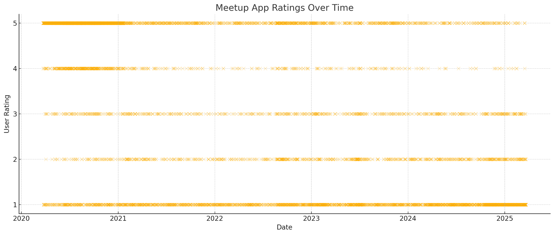
(Below) MeetUp Review Scores, last 5 years. United States only.
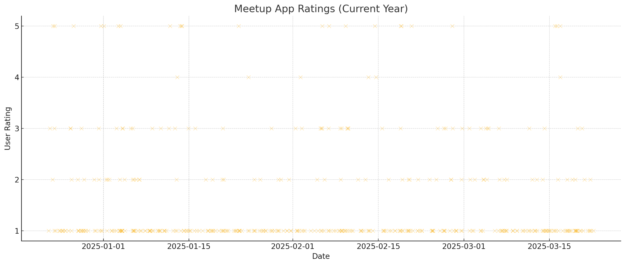
MeetUp’s App User Scores. User Ratings from Last 5 Years, All Countries
MeetUp’s App User Scores. Last 5 years. United States only.
Competitor Analysis 2 - Nextdoor:
Overview: Brief Introduction of Nextdoor
Nextdoor was first created in 2011 with the intention of allowing neighbors to privately communicate with each other through a social platform. At the time, with the rise of other social media platforms such as Facebook and Instagram, locals were looking for a similar platform that would allow them to communicate with others nearby and through that came “Nextdoor”. The website/app is a local, neighborhood app specialized in providing a private social network for residents to connect, share local information, and build community.
Features and Offerings
In the past decade, the website/app has gained lots of features within the app such as public group chats, ability to discover local businesses, meet others with similar interests, discover what events are happening in the area, and private “street” group chats. Within these street group chats, only verified residents within a block can enter the chat and interact with others. In these chats, locals can ask questions, share updates, buy, sell, or borrow items. Additionally, users can block each other, create posts similar to Instagram, and also see what topics/posts are trending in the app.
Hands-on Evaluation and First Impression
Upon further inspection, from the moment a user opens the site, it prompts the user with a simple “Log-in” or “Register” page. Once the user registers, a series of questions are asked such as “What’s your address?” or “What groups are you interested in?”. After an account is established, the site seems pretty easy to navigate. The menu/navigation bar showcases options such as Home, For Sale & Free, Chats, Notifications, Groups, Events, Invite Neighborhoods, and Post. There are also buttons that allow the user to view all posts that are Recent, Nearby, or Trending. As the user scrolls through their feed, they can view all sorts of posts ranging from people offering services, asking for recommendations, updating others on city events, complaining about loud vehicles, telling stories, asking for help when moving items, and a frequent topic was (lost or found) animals. In between posts, there are also lots of advertisements from local and non-local companies. Most mentioned services for remodeling or discounts/deals for department stores. Furthermore, the user can view all of their posts within their Profile section, and they can also earn rewards for making frequent posts that fall under that category, although there are no clear instructions on how to earn them. Some awards were “Biz Supporter, Convo Starter, Party Planner, and Visual Artist”. All in all, the usability of the website seems very user-friendly and the navigation bar simplifies things by a lot. There you can access all features, the Post button is a bright green color, and you can explore other neighborhoods. Also within the groups section, people can easily create their own groups about any topic. Furthermore, most of the advertisements were related to home renovation and services for maintenance, but there were occasionally some irrelevant advertisements that mentioned webinars and other random services.
Stand Out Features
Moreover, there was an “Events” feature that stood out. Within this section, there were some local events such as “Jigsaw puzzle swap/exchange” but there were also a lot that were random such as “Don’t let market volatility destroy your retirement”. Other events looked like they were clearly placed by businesses such as “Bites and Brews Happy Hour at ISM Brewing in Long Beach”. While it is beneficial for businesses to advertise themselves within the events section, it does not show a true representation of what the community is interested in. If a user were to propose meeting up at a business and hanging out there, it would show initiative to hang out rather than a business planting an event. In like manner, most of these events looked like they were also placed by traveling entertainers or other cities, although there is an exception of 2 actual local events. This similar sentiment applies to posts as well. While there were locals posting about their regular day, there were a lot of posts that just revolved around services. So the posts related to services paired with business advertisements gives the feeling that the user is on some sort of marketplace rather than a neighborhood app that is founded on connecting with others in the area.
User Reviews and Ratings
Nextdoor’s User Scores. User Ratings from last 5 years, United Kingdom
(International)
Overall Rating: 2.7
Nextdoor’s User Scores. User Ratings from last 5 years, United States (National)
Overall Rating: 1.2
Opportunity Assessment:
SWOT Analysis:

STRENGTHS | WEAKNESSES
- Map Visualization  - Localized Focus  - Building community | - Getting users to switch to us  - Limited reach  - Moderation challenges
OPPORTUNITIES | THREATS
- Local business connections  - Event promotion  - In-App shop feature | - Competitors  - Privacy concerns  - Safety concerns

A few strengths of our app will be a map visualization, localized focus, and a way to build a stronger community. When using the app, there will be a map displaying your current location and where you are at. Around you on the map will be pins placed by people who have reported or announced something in that spot. This allows for a more interactive and interesting way of being able to show what is happening around the local area. Another strength is the localized focus of the app. Being able to limit yourselves to your own local communities will allow for better engagement and trust, as interacting with likely familiar faces is more comfortable to most people. As for building a stronger community, this ties back into the localization point. Since there is a bigger focus for the local aspects of the app, it will ensure that a community will be built up overtime the more the app is used.
For the weaknesses, a significant one is the way to convince users to switch to our app. People tend to stay on the current existing local communications apps because the app that they are already using does what they need. So, without a proper way to distinguish ourselves from our competitors, there would be no reason for people to swap from the current existing local communication apps to ours. Next is the limited reach the app will have. The app being targeted towards local communications means that the outreach of the app won’t be as useful outside of that local area and the growth of the app could also be limited because of it. Lastly, moderation challenges will pose an annoying challenge to overcome. Other current local communications apps already struggle to moderate their own apps, which proves that it will be difficult for us too. It requires a good bit of effort to be able to automatically or manually remove posts that don’t follow guidelines.
There are a multitude of opportunities for our app, such as local business connections, event promotions, and other features for the app. Having local business connections for our app will not only make it easier for users to find the local business, but also promotes that business to more people. This can lead to possible collaboration efforts to create better engagement for them and the community. Similarly with the previous point, having event promotions for our app will make it easier for users to find that specific event, promote it to a bigger outreach of people, and even have potential collaboration with the events. Lastly, there can be a shop section for the app where you can do your in-app purchases for profile cosmetics. These purchasable profile cosmetics can add extra flair to your profile and customize it to your liking if the free options aren’t enough, offer limited time seasonal cosmetics, and other shop items to create more investment into the app.
Finally, the threats to our app include competitors, privacy, and safety concerns. The main competitors to our app will be MeetUp and Nextdoor. These apps are a dominant force in this space, as they are already so well established in the market, so it will be difficult to compete against them. Privacy is also another threat that we have to address, since handling it improperly will lead to a variety of severe problems, ranging from legal issues to exposing sensitive information of our users. This leads to the next threat, safety. Without taking the proper measures to ensure the user’s safety as much as possible, they could fall for scams, or worse, be put in danger. So, similar to the previous point, it needs to be handled properly in order to ensure that all our users stay safe from malicious actors.
Gap Analysis:
Strategic Positioning:
Differentiation:
Compared to our competitors, we plan on having a more in-depth social media and socialization platform. Although other apps do offer a degree of social features that allow users to talk and socialize with one another, they lack the function that allow users to actually meet up and hang out. This aspect is sorely needed with the disappearance of third-spaces, people are socializing in-person less and less. This is what will make The Bulletin different from what our competitors can offer.
One core differentiating feature that we plan to implement is a real-time chat function. This feature will allow users to talk to one another in real-time without having to make a post and wait for replies. This function will best be used to quickly and immediately talk to the people around you, such as sharing information and discussing recent events, and will facilitate quick and casual conversations among users in an area. One potential idea for the chat function is that we can implement temporary screen names which refresh after a certain time period, such as a week. This way, users that host or attend events can’t have their identities figured out without their consent, thus giving them an extra layer of anonymity that would be necessary for a platform such as The Bulletin. Following this, we can Another core feature of The Bulletin will be its visual map that users can post pins on--creating events that other users can view and even attend. With this feature, users can simply look on a map and see what pins are nearby and can immediately know where these events are and how far away they are without having to jump through hoops to find an address and putting it into a navigation app just to figure out it was too far away for them to want to go to it. An additional feature for the pins is that they only last for a few days and aren’t meant to be permanent mainstays, thus clearing the map of clutter and allowing other people to make their own pins while also limiting the amount of time that information to events is available, increasing user privacy of the event hosters.
Many of our competitors have similar features and functions to one another, but none of them will have the same comprehensive social aspect that The Bulletin will. By building The Bulletin around these features, we will differentiate it from our competition and it will create a platform that fits into a gap in the market that has thus far been left unfilled.
Differentiation Matrix:
Potential Challenges:
First and foremost, a major concern that we found during our interview stage was privacy and security. The idea of meeting people through the internet and going to events with said people can be unnerving, especially considering you don’t know what they’re actually like. Furthermore, within the online platform itself, you can run the risk of chats being leaked, or identities and locations being doxxed--additional concerns from our interviewees. Interviewees also stressed their dislike of the collection and sale of their personal user data on other social media platforms. Another challenge would be monetization. As much as we would like to have The Bulletin be completely free from a user perspective, it’s just not realistic with running a server (or multiple) and any API costs we may accrue. Furthermore, having financial gain from the platform can help us potentially expand the scope and features of The Bulletin, but that’s for down the line.
To tackle the issue of event safety, we can implement ways to gauge how many people would be attending an event, such as through an RSVP system or a way to show how many likes are on a post which would show users’ interest. This way, users can feel safe knowing that an event will have a lot of attendees. For ensuring the safety of our users’ identities, we can implement encryption so that chats cannot be leaked via external hacking. Furthermore, we can have users’ locations be recorded as being from a broad area, rather than one specific location (e.g. being somewhere in a certain ZIP code versus being at an address) so that neither hackers nor other users can track any individual user down. In the area of data privacy, we can implement account settings that allow users to control what information is being collected and how they can be used so that users can have confidence that their user is not being collected and sold against their consent. Much like other “free” platforms, we can implement certain paid features in order to make money to keep The Bulletin running. Some interviewees stated that they didn’t mind premium features as long as the core features were accessible and usable. In addition, they didn’t mind paying for the premium as long as the benefits outweighed the costs. One method is that we can implement unobtrusive advertisements, similar to older web pages that have ads built in and not as a pop-up or an unskippable 30 second video as with some streaming websites. Another would be to have premium features that enhance the core features of The Bulletin. For instance, users could pay a monthly fee to be able to view a bigger map and have the ability to post more pins compared to free users. These are just a few strategies that we can undertake to mitigate what are going to be the biggest challenges in creating The Bulletin as we go forward.
Conclusion:
Summarization:
Our market analysis has shown a demonstrable gap within the local interaction space. Current competitors focus on already defined groups, fail to take advantage of the increased availability of user geolocation data, or are limited in the space you can interact in. MeetUp and other social media platforms require already being acquainted with a group before finding content relating to your location. Nextdoor and Ring are limited within reach to one’s neighborhood and thus shrinking the space people can interact with.
We wish to fill the gap by helping users interact with those nearby beyond one’s neighborhood while staying local by assigning posts and public events to pins on a map and to dynamically the users’ visibility and/or interactivity with pins depending on geolocation. By displaying content on a map, users will have a streamlined experience checking up around them at a moment's notice anywhere in the world. To ensure sustainability of The Bulletin and its users, we need to explore ways to achieve funding like user customization or partnerships, keep users' information secure (location approximation, anonymization, encryption), and provide tools like event interest to inform users in an honest fashion.
Implications:
Based on our market research, it is implying that we need to make sure to address what people are looking for most from local communication apps. We have to include local integration, user privacy, and community in order to compete with the top apps. Without addressing these key market shifts and trends, we won’t be able to have a chance at competing in the market.
As for our next steps, we will need to ensure that privacy will not be violated to build trust with our users. This is probably the most important finding from our market research, as this seems to be a common trend for all of the apps in the local communications market. People do not want information about them to be not secured or private when in the hands of these companies. Then, we will have to focus on how we can do local integration within our app, which will also lead to improving the community aspect of it. Since we want to compete in the market of local communications apps, this is essential in order for us to go against our competitors. Without coming up with some ways to do this, long term success will be difficult for our app.
Appendices:
Competitor Features:
Application Features | MeetUp | Nextdoor | Citizen | Eventbrite | Snapchat
Location-Based Events | ✅ | ❓ | ❓ | ✅ | ❓
User Events | ✅ | ✅ | ⛔ | ✅ | ✅
Visual Map Feature | ⛔ | ❓ | ✅ | ✅ | ✅
Anonymous Options | ⛔ | ⛔ | ❓ | ⛔ | ❓
Local Chat | ✅ | ⛔ | ⛔ | ⛔ | ⛔
Image Sharing | ✅ | ✅ | ✅ | ⛔ | ✅
Mobile Application | ✅ | ✅ | ✅ | ✅ | ✅
Verification | ✅ | ✅ | ✅ | ✅ | ✅
Self-Destruct Messages | ⛔ | ⛔ | ✅ | ❓ | ✅

MeetUp Reviews:
MeetUp has lots of mixed reviews and ratings, but the majority of the ratings are between 4 and 5 stars (66% of ratings were 4 stars and above). Users who rated 4 stars and above appreciated community engagement and saw recent improvements within new API features that allowed translation. Those who rated 3 stars gave it a satisfactory review while those who rated below a 2 reported that the app glitched, had log-in issues, difficulty navigating the interface, and concerns over the app becoming heavily commercialized, as well as privacy concerns. Some suggestions that the reviewers had were for the app to address the app’s glitches, technical bugs, and improve the privacy controls and permissions. Additionally, a user mentioned that the app had charged their account a day earlier than expected after a free trial. They stated “I recently signed up for a one-week trial period, however, to my surprise, on the third day of the trial, I discovered that Meetup had charged me an unauthorized amount of $500! I am now faced with the frustrating task of pursuing a refund from their customer support team. I hope that Meetup will address this issue promptly and efficiently, as this experience has left me disappointed in their service.”
Nextdoor Reviews:
Similarly, Nextdoor has lots of mixed reviews, although a majority are 2 stars and lower (55.19% of ratings are 2 stars and below). While users who rated 4 stars and above found the app to have an easy setup process and nice interface, many of the other reviewers found several flaws. Other users who rated 2 stars and below found that the Search and Event pages were often useless, there were privacy concerns over excessive data collection, and moderation over content was a concern as well. Additionally, many users found it hard to get rid of the app and their information within it. They found that they would get continuous emails long after they had deleted their account. For example, a user stated, “Don't sign up!!! The emails you get are absolutely and utterly ridiculous and they make it impossible to unsubscribe. I'm talking several times a day, every day, AFTER I tried to unsubscribe from the hundreds of categories of ‘notifications’”. Meanwhile, some improvements that users suggested were for the Search bar to have better functionality and for privacy concerns to be addressed.
Backup Data:

Citations:
“Can Eventbrite’s Growing Ticket Volume Offset Its Widening Losses? Q4 Earnings Analysis.” Eventbrite Q4 Earnings: Revenue Hits $76.5M Despite 13% YoY Decline, Ticket Volume Grows | EB Stock News, StockTitan, 27 Feb. 2025, www.stocktitan.net/news/EB/eventbrite-reports-fourth-quarter-2024-financial-vu47has5pne1.html#:~:text=Eventbrite%20(NYSE%3A%20EB)%20reported,million%20loss%20in%20Q4%202023.
Dkramer@nextdoor.com. “Nextdoor Reports Fourth Quarter and Full Year 2024 Results.” About Nextdoor, 27 Feb. 2025, about.nextdoor.com/press-releases/nextdoor-reports-fourth-quarter-and-full-year-2024-results/.
“Meetup Revenue: Annual, Quarterly, and Historic.” Zippia, 21 July 2023, www.zippia.com/meetup-careers-74297/revenue/#.
“Report: Citizen Business Breakdown & Founding Story: Contrary Research.” Report: Citizen Business Breakdown & Founding Story | Contrary Research, research.contrary.com/company/citizen. Accessed 28 Mar. 2025.
“Snap Inc.. Announces Fourth Quarter and Full Year 2024 Financial Results.” Snap Inc. - Snap Inc. Announces Fourth Quarter and Full Year 2024 Financial Results, investor.snap.com/news/news-details/2025/Snap-Inc.-Announces-Fourth-Quarter-and-Full-Year-2024-Financial-Results/default.aspx. Accessed 28 Mar. 2025.
“US - Nextdoor Is Rated ‘Bad’ with 1.2 / 5 on Trustpilot.” Trustpilot, www.trustpilot.com/review/nextdoor.com. Accessed 29 Mar. 2025.
“UK - Nextdoor Is Rated ‘Poor’ with 2.7 / 5 on Trustpilot.” Trustpilot, www.trustpilot.com/review/nextdoor.co.uk. Accessed 29 Mar. 2025.

Introduction

Recap 0.75
- Recap of the refined project idea stemming from the user-centered design activity.
Our initial concept was to create a local focused social media program where people can post freely about whatever they want, and visibility of posts are tied directly to the closeness to the user. This initial concept was rooted in the belief that hyper-localized content could foster stronger community connections and make it easier for users to discover events and interact with their local community. We prioritized proximity, ensuring that users would see posts relevant to their local surroundings. That initial conception guided our questions and interviewing process.
From the user-centered design research we refined the project idea to as follows. The app will contain 3 main pages the user can select from. The “Board” page, the Map page, and the Chat page. The app’s main screen is an “infinite feed” of discrete and unique Pins where users may continue scrolling to see Pins posted by others sorted by distance. Inspired by forums much more common in the earlier days of the Internet, this Pins functions similar to a typical internet forum’s thread system. Pins may include an image or no image, and a necessary text submission alongside it. If a Pin interests a user, they may click on the Pin to open up that Pin page which may include more details about the event, and replies.
The Map section of the app will include a standard Mercator projection map where users may interactively see what Pins are close to them. This includes zooming in and out, pressing on Pins, and viewing. However, this map is still constrained to a local area, so users may not see Pins that are too far away from their current location.
Lastly, the Chat page. In this page there will be a free flowing chat where message visibility is constrained by how close messages are to the user’s current location. Users may send out messages into the chat, and only those within the users’ radius may see those messages.

Significance of Market Research 0.75
Significance of this market research in the context of the project.
The market research conducted through 17 interviews was instrumental in shaping the direction of the project. From the pain points and concerns, we are able to get a better idea of what use users can get out of our app. Through our user interviews and analysis, we identified pain points in communication, such as over-reliance of word of mouth, fragmented small group communities, and lack of intuitive tools for event discovery. In addition to those pain points, we identified the following concerns. Interviewees had concerns over location tracking, data sharing and selling, event legitimacy, and content moderation.
Over-Reliance on Word of Mouth was cited as an issue for interviewees. This pain point legitimized the need for an easy place to post local event information without the stress of being seen worldwide. Our platform serves as a centralized place to post and discover local events. Allowing users to easily create Pins with images and supplemental text, this affords users great freedom in how they want to express themselves with their local community.
Small group communities are fragmented. Interviewers spoke about how they might may be a part of many regular groups but must keep track of many different events through many different means. This concern informed our design by being a single unified space for seeing local events.
Lack of Intuitive Tools for Event Discovery was a commonality between participants in our market research. Our answer to this pain point was to create a map of pins. This map tool affords the user intuitive event discovery. In addition to our map tool, sorting by distance in the Board section helps alleviate some of the analysis paralysis that comes with discovering the events in a locality.
Interviewers also spoke on Concerns Over Event Legitimacy. Our approach to this problem is two fold. We intend to combat this issue by requiring users to sign up with phone number verification. This ensures that events are posted by real people, and adversarial attacks against the system are much harder to scale. In addition to phone number verification, we also intend add event attendance tracking to allow users to gauge event interest.
Lastly, interviewers had Concerns Over Content Moderation. This insight helped guide us towards a 3 pronged approach. First, users may report harmful posts which will be reviewed by moderators. Secondly, we intend to add automated content filters to block obviously harmful content and spam. Lastly, we intend to add Clear Community Guidelines to help users reference what is allowed content on the app.
These pain points and concerns guided us to address what users truly need to enhance the local interaction space. By tackling issues such fragmented communication, event legitimacy, and content moderation, we’ve designed a solution that will provide value to users in discovering local happenings and events. The insights over concerns with the app concept have been invaluable to the current design and what problems need to be addressed before shipping the application out into the world. Moving forward, these discoveries will serve as a foundation for our project as we continually iterate this project. Our refined solution will bridge the gap between the current state of local communication

Market Overview

Market Size and Growth Trend
Market Overview: Market Size and Growth Trend:
Some competitors that more closely compete in the local event sphere are private and thus will be difficult to ascertain metrics on. In light of that, some general purpose social media apps are included to demonstrate general market size and growth trends.

This graph displays a straight best fit line over the logarithmic revenues for each company in the list. This shows us exponential growth for all of the companies listed. There is consistent relative change.
In this graph of Year over Year % change, we can see that Facebook, Snapchat, and Nextdoor have an convex upward curve best fit line. This indicates that these company’s growth is increasing, but the rate of growth is decreasing. This indicates reaching market saturation. Eventbrite has a concave down and decreasing best fit line. This indicates that losses are worsening and an increasing rate overtime.

Major Players and Market Share
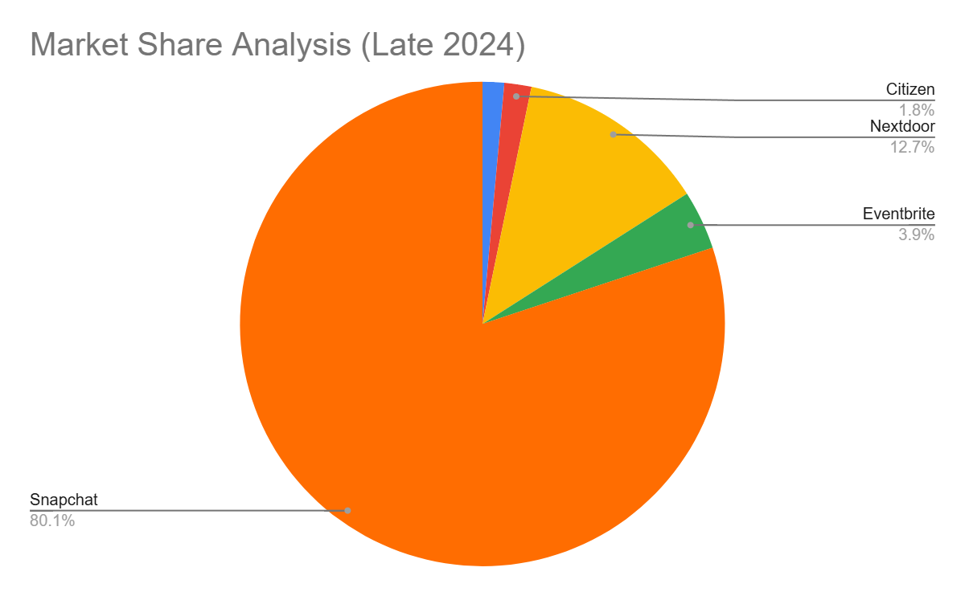
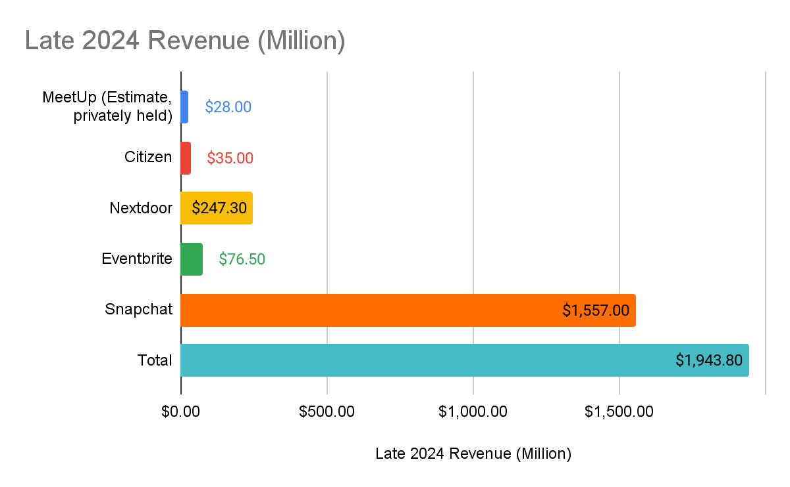
 | Late 2024 Revenue (Million) | Market Share
MeetUp (Estimate, privately held) | $28.00 | 1.44%
Citizen | $35.00 | 1.80%
Nextdoor | $247.30 | 12.72%
Eventbrite | $77 | 3.94%
Snapchat | $1,557 | 80.10%
Total | $1,943.80

General observations
The market for local communications apps is difficult to determine, as specific data on these apps are limited. But, this type of app is essentially a subset of the various communications apps. This means that whatever happens in those markets there, will also likely affect the market for the local communications apps.
When trying to figure out the current value of the market for local communications apps, it is at least $310 million USD with all of the largest apps combined (Nextdoor, Citizen, and MeetUp). Nextdoor was the largest of the 3, valuing at around $247 million, which is almost 80% of the local communications market. Their value was a sizable increase from the last year, with a 13% increased revenue from the previous year. As for Citizen, it was valued at an estimated $35 million, and for MeetUp, it was valued at about $28 million.
Currently, the market for global and local social networking, instant messaging, and mobile messaging apps all show a promising future for this market. As of right now, the market for all of these apps are valued at billions of dollars in total. Not only that, they are also showing no signs of slowing down in the future either. This is because of a combination of multiple factors; people wanting local integration, user privacy, and community.

Competitor Analysis
For Each Competitor:
• Overview: Brief introduction.
• Features & Offerings: Tabulated comparison of features among competitors.
• Hands-on Evaluation:
• First impressions.
• Usability and user experience insights.
• Standout features or notable gaps.
• User Reviews & Ratings: Scatter plot or bar graph representing user ratings and reviews for each competitor (if available).

Competitor 1: MeetUp
Overview: Brief Introduction of MeetUp

In 2002 a new website showed face on the internet to streamline the ever increasing connectedness of locals in their respective neighborhoods. At the time it was quite remarkable - smartphones wouldn’t be released for another 5 years and the word ‘app’ wasn’t part of everyday language. Instead of phone dialing all your neighbors and getting stuck in an undesired conversation for hours on end, you could simply plan an event on their website. Anyone could register and the service was free. Fast forward to today and now we have the mobile application. Join a local group, join the group's event, and meetup. However, unlike the original 2002 MeetUp, current market MeetUp comes with a lot more nuances which affect everything: from market growth to user experience, and to insights regarding the overall market of local citizen communication tools.

Features & Offerings:

Application Features | MeetUp | Nextdoor | Citizen
Location-Based Events | ✅ Yes | ❓Just post, not events | ❓Only for Emergencies
User Events | ✅Yes | ✅Yes | ⛔Only Crime Reports
Visual Map Feature | ⛔No | ❓Only Lost and Found | ✅Yes, for current incidents.
Anonymous Options | ⛔No | ⛔No | ❓Partially, only alerts
Local Chat | ✅Yes | ⛔No, Voting only | ⛔No
Image Sharing | ✅Yes, for Event | ✅Yes | ✅Yes
Mobile Application | ✅Yes | ✅Yes | ✅Yes
Verification | ✅Organizer Discretion | ✅Real Name and Address | ✅Verifying Reports
Self-Destruct Messages | ⛔No | ⛔No | ✅Yes, alerts fade.

It should be mentioned that Citizen isn’t so much a direct competitor, but more so the only other popular application for local communication. It comes with great surprise in such a short timeframe we found ourselves pulling for scraps. A lot of other competitors are more indirect: such as Facebook Groups or Telegram groups. To develop a full table of features against competitors who satisfy strictly the requirement of local communication is difficult to come by. It’s worth repeating a key insight of our presentation for Milestone 2: fragmentation. Since applications tend to provide very broad tools, what defines a potential competitor is actually a very difficult question to answer. However, the generalization of modern applications can also be an opportunity to satisfy very specific demands in the marketplace.

Hands-on Evaluation, aka “Give us your credit card just to see the application.”

First Impressions: “Pay me $2.99 for a First Impression”
While first impressions can prove to be extremely insightful in the nature of what an application is, presenting this image of subscription fees will largely carry this first impression. For context, the option “Try for $2.99/month” and “Try for Free” both lead to the same page. Before we have seen the application the user is presented with the illusion of choice and is required to give their credit card information. From a security standpoint this makes a lot of sense. Telegram and Discord both have automated bot problems since accounts are free. However, the user hasn’t even seen the application yet! What does the user interface look like? How does it work? What does the application look like in action? Most individuals are well aware of the fact that companies exploit user forgetfulness to unsubscribe before the next billing statement. Needlessly to say, but users have to pay money for a first impression.

Usability and user experience insights
Before a user can even browse, they must join a group. All events are tied directly to a group. To begin browsing, it’s ideal then to simply join as many groups as possible, since there’s no visibility of both something of interest and an event tied to it without doing so. Meetup works in a more classic manner in simply giving users the address of the event, but no visual map indicating where the event might be. This can be quite problematic when planning events at parks where you may give out the address of the parking lot, but not the actual reserved location for the event. But overall the application is straight forward: plan an event, drop the address to everyone in the group, and off they go.
Planning and executing are never quite one for one. This goes not only for events themselves, but the MeetUp application itself. But before diving into user experience insights a tangent must be taken : the Google Play Terms of Service. One action in particular that violates this is “using automated means to access content from any of our services…” This includes user reviews, at least that’s what many believe since Google doesn’t pursue every violator of such Terms of Service. In the age of AI however it doesn’t take long for Language Models to scrap this data if their internal constraints are tweaked to ignore this. One may argue the reason people aggregate user insights is because the Google Play Store Page doesn’t make it easy. Users have to scroll manually since reviews are loaded in small bunches. The review system is also done in stars which means the results simply can’t be copy and pasted. Under the hood, it gets complicated quickly for pulling meaningful reviews and trying to judge if the review is legitimate or done by a bot to inflate the application’s score.

Past the uphill-both-ways of pulling user reviews lies the original goal: insight into the app. To avoid disorganization, various photos of user reviews will be posted in the appendices of what is discussed here. Taking our first step into the MeetUp app we are immediately bombarded with feedback. Users can’t login with their Google account, the application freezes, and trying to make a new account results in “an account already exists for that.” Should a user get past this bumpy start there’s the fact the application requires permissions. But apparently giving the MeetUp application full permission to use a phone's built-in Calendar system doesn’t work. So does MeetUp require even more permissions just to add events to the user calendar? There is no further clarification as to why such a simple feature doesn’t work. So, let’s take a moment to zoom out from the swamp of complaints on basic features not working and discuss money.

Money may make the world go around, but money verifies you’re real on MeetUp. The topic of verification has been brought up extensively: whether it’s by 2-factor authentication, age verification through a government tool ,or moderator approval by sending pictures of your driver's license. With money on MeetUp you get higher priority in waitlists. You want to be able to send multiple messages to a friend in a single day? Money will let a user do that. Want to check who is going to the event? That last question requires breaking professionalism for a moment. Having to spend money to find out who's attending your own event is atrocious and highly suspicious. If a user can’t obtain even the most basic information on who's attending an event, then that’s simply exploiting the user's ignorance. This design philosophy borders on exploitation, since paying for basic information is a major ethical and accessibility concern.
Standout features or notable gaps

Observation of past overwhelming user frustrations isn’t without merit. As one might guess, MeetUp is a competitor from a technical perspective. In fact, MeetUp’s last popularity spike was in 2012. Finding standout features on MyMeet proved difficult because the market has drastically changed in the last 10 years. Perhaps in 2012 it proved to be the best solution. But now it pales in comparison to other companies who give tools exponentially more powerful - and without the paywall. When Nextdoor (the next competitor) and MeetUp are removed from the equation, we get a surprising result: nothing. But nothing means there’s a gap in the market. During the team’s presentation it was discussed how there’s an oversaturation in the market. This is primarily the result of indirect competitors who may not specialize in local communication, but have tools that just happen to facilitate it. Tools for specialized local event planning simply don’t exist on a large scale, but perhaps it’s time for that change.

User Reviews & Ratings
(Below) MeetUp Review Scores, past 5 years. All countries.
(Below) MeetUp Review Scores, last 5 years. United States only.

MeetUp’s App User Scores. User Ratings from Last 5 Years, All Countries
MeetUp’s App User Scores. Last 5 years. United States only.

Competitor 2: Nextdoor
Overview: Brief Introduction of Nextdoor
Nextdoor was first created in 2011 with the intention of allowing neighbors to privately communicate with each other through a social platform. At the time, with the rise of other social media platforms such as Facebook and Instagram, locals were looking for a similar platform that would allow them to communicate with others nearby and through that came “Nextdoor”. The website/app is a local, neighborhood app specialized in providing a private social network for residents to connect, share local information, and build community.
Features and Offerings
In the past decade, the website/app has gained lots of features within the app such as public group chats, ability to discover local businesses, meet others with similar interests, discover what events are happening in the area, and private “street” group chats. Within these street group chats, only verified residents within a block can enter the chat and interact with others. In these chats, locals can ask questions, share updates, buy, sell, or borrow items. Additionally, users can block each other, create posts similar to instagram, and also see what topics/posts are trending in the app.
Hands-on Evaluation and First Impression
Upon further inspection, from the moment a user opens the site, it prompts the user with a simple “Log-in” or “Register” page. Once the user registers, a series of questions are asked such as “What’s your address?” or “What groups are you interested in?”. After an account is established the site seems pretty easy to navigate. The menu/navigation bar showcases options such as Home, For Sale & Free, Chats, Notifications, Groups, Events, Invite Neighborhoods, and Post. There are also buttons that allow the user to view all posts that are Recent, Nearby, or Trending. As the user scrolls through their feed, they can view all sorts of posts ranging from people offering services, asking for recommendations, updating others on city events, complaining about loud vehicles, telling stories, asking for help when moving items, and a frequent topic was (lost or found) animals. In between posts, there are also lots of advertisements from local and non-local companies. Most mentioned services for remodeling or discounts/deals for department stores. Furthermore, the user can view all of their posts within their Profile section, and they can also earn rewards for making frequent posts that fall under that category, although there are no clear instructions on how to earn them. Some awards were “Biz supporter, Convo Starter, Party Planner, and Visual Artist”. All in all, the usability of the website seems very user-friendly and the navigation bar simplifies things by a lot. There you can access all features, the Post button is a bright green color, and you can explore other neighborhoods. Also within the groups section, people can easily create their own groups about any topic. Furthermore, most of the advertisements were related to home renovation and services for maintenance, but there were occasionally some irrelevant advertisements that mentioned webinars and other random services.
Features that stand out
Moreover, there was an “Events” feature that stood out. Within this section, there were some local events such as “Jigsaw puzzle swap/exchange” but there were also a lot that were random such as “Don’t let market volatility destroy your retirement”. Other events looked like they were clearly placed by businesses such as “Bites and Brews Happy hour at ISM Brewing in Long Beach”. While it is beneficial for businesses to advertise themselves within the events section, it does not show a true representation of what the community is interested in. If a user were to propose meeting up at a business and hanging out there, it would show initiative to hang out rather than a business planting an event. In like manner, most of these events looked like they were also placed by traveling entertainers or other cities, although there is an exception of 2 actual local events. This similar sentiment applies to posts as well. While there were locals posting about their regular day, there were a lot of posts that just revolved around services. So the posts related to services paired with business advertisements gives the feeling that the user is on some sort of marketplace rather than a neighborhood app that is founded on connecting with others in the area.
User Reviews and Ratings
Nextdoor’s User Scores. User Ratings from last 5 years, United Kingdom (International)
Overall Rating: 2.7
Nextdoor’s User Scores. User Ratings from last 5 years, United States (National)
Overall Rating: 1.2

Opportunity Assessment

SWOT Analysis
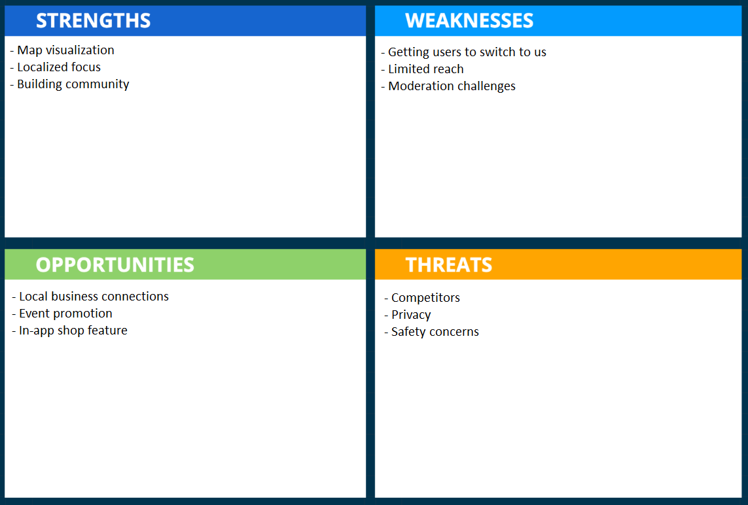
A few strengths of our app will be a map visualization, localized focus, and a way to build a stronger community. When using the app, there will be a map displaying your current location and where you are at. Around you on the map will be pins placed by people who have reported or announced something in that spot. This allows for a more interactive and interesting way of being able to show what is happening around the local area. Another strength is the localized focus of the app. Being able to limit yourselves to your own local communities will allow for better engagement and trust, as interacting with likely familiar faces is more comfortable to most people. As for building a stronger community, this ties back into the localization point. Since there is a bigger focus for the local aspects of the app, it will ensure that a community will be built up overtime the more the app is used.
For the weaknesses, a significant one is the way to convince users to switch to our app. People tend to stay on the current existing local communications apps because the app that they are already using does what they need. So, without a proper way to distinguish ourselves from our competitors, there would be no reason for people to swap from the current existing local communication apps to ours. Next is the limited reach the app will have. The app being targeted towards local communications means that the outreach of the app won’t be as useful outside of that local area and the growth of the app could also be limited because of it. Lastly, moderation challenges will pose an annoying challenge to overcome. Other current local communications apps already struggle to moderate their own apps, which proves that it will be difficult for us too. It requires a good bit of effort to be able to automatically or manually remove posts that don’t follow guidelines.
There are a multitude of opportunities for our app, such as local business connections, event promotions, and other features for the app. Having local business connections for our app will not only make it easier for users to find the local business, but also promotes that business to more people. This can lead to possible collaboration efforts to create better engagement for them and the community. Similarly with the previous point, having event promotions for our app will make it easier for users to find that specific event, promote it to a bigger outreach of people, and even have potential collaboration with the events. Lastly, there can be a shop section for the app where you can do your in-app purchases for profile cosmetics. These purchasable profile cosmetics can add extra flair to your profile and customize it to your liking if the free options aren’t enough, offer limited time seasonal cosmetics, and other shop items to create more investment into the app.
Finally, the threats to our app include competitors, privacy, and safety concerns. The main competitors to our app will be MeetUp and Nextdoor. These apps are a dominant force in this space, as they are already so well established in the market, so it will be difficult to compete against them. Privacy is also another threat that we have to address, since handling it improperly will lead to a variety of severe problems, ranging from legal issues to exposing sensitive information of our users. This leads to the next threat, safety. Without taking the proper measures to ensure the user’s safety as much as possible, they could fall for scams, or worse, be put in danger. So, similar to the previous point, it needs to be handled properly in order to ensure that all our users stay safe from malicious actors.

Gap Analysis
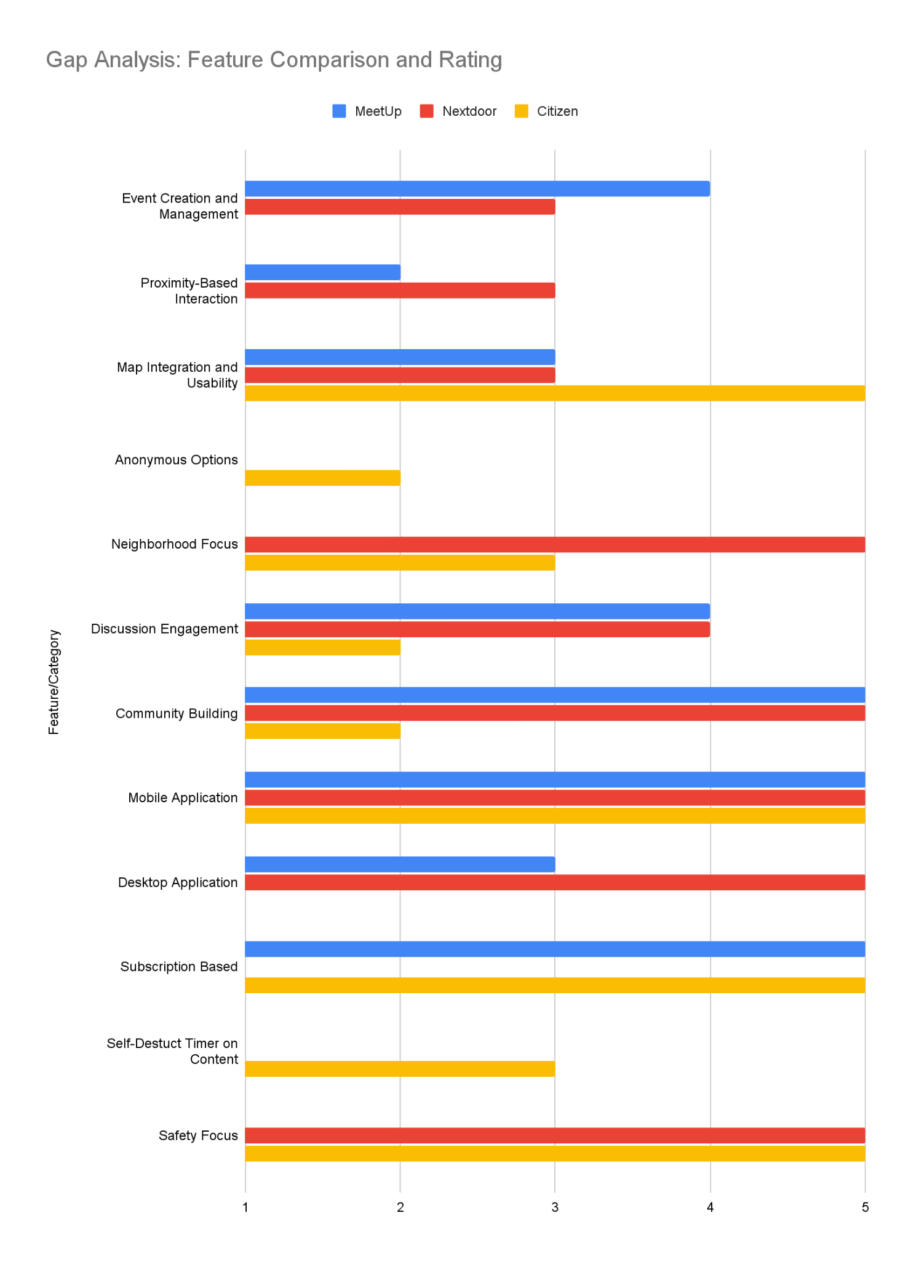

Strategic Positioning

Differentiation
Discussion on how your project differentiates from competitors.

Compared to our competitors, we plan on having a more in-depth social media and socialization platform. Although other apps do offer a degree of social features that allow users to talk and socialize with one another, they lack the function that allow users to actually meet up and hang out. This aspect is sorely needed with the disappearance of third-spaces, people are socializing in-person less and less. This is what will make The Bulletin different from what our competitors can offer.
One core differentiating feature that we plan to implement is a real-time chat function. This feature will allow users to talk to one another in real-time without having to make a post and wait for replies. This function will best be used to quickly and immediately talk to the people around you, such as sharing information and discussing recent events, and will facilitate quick and casual conversations among users in an area. One potential idea for the chat function is that we can implement temporary screen names which refresh after a certain time period, such as a week. This way, users that host or attend events can’t have their identities figured out without their consent, thus giving them an extra layer of anonymity that would be necessary for a platform such as The Bulletin. Following this, we can Another core feature of The Bulletin will be its visual map that users can post pins on--creating events that other users can view and even attend. With this feature, users can simply look on a map and see what pins are nearby and can immediately know where these events are and how far away they are without having to jump through hoops to find an address and putting it into a navigation app just to figure out it was too far away for them to want to go to it. An additional feature for the pins is that they only last for a few days and aren’t meant to be permanent mainstays, thus clearing the map of clutter and allowing other people to make their own pins while also limiting the amount of time that information to events is available, increasing user privacy of the event hosters.
Many of our competitors have similar features and functions to one another, but none of them will have the same comprehensive social aspect that The Bulletin will. By building The Bulletin around these features, we will differentiate it from our competition and it will create a platform that fits into a gap in the market that has thus far been left unfilled.

Differentiation Matrix
Differentiation Matrix: A table or 2D scatter plot comparing your project against competitors based on two major factors (e.g., usability vs. feature set).

Potential challenges
Potential challenges and strategies to address.
First and foremost, a major concern that we found during our interview stage was privacy and security. The idea of meeting people through the internet and going to events with said people can be unnerving, especially considering you don’t know what they’re actually like. Furthermore, within the online platform itself, you can run the risk of chats being leaked, or identities and locations being doxxed--additional concerns from our interviewees. Interviewees also stressed their dislike of the collection and sale of their personal user data on other social media platforms. Another challenge would be monetization. As much as we would like to have The Bulletin be completely free from a user perspective, it’s just not realistic with running a server (or multiple) and any API costs we may accrue. Furthermore, having financial gain from the platform can help us potentially expand the scope and features of The Bulletin, but that’s for down the line.
To tackle the issue of event safety, we can implement ways to gauge how many people would be attending an event, such as through an RSVP system or a way to show how many likes are on a post which would show users’ interest. This way, users can feel safe knowing that an event will have a lot of attendees. For ensuring the safety of our users’ identities, we can implement encryption so that chats cannot be leaked via external hacking. Furthermore, we can have users’ locations be recorded as being from a broad area, rather than one specific location (e.g. being somewhere in a certain ZIP code versus being at an address) so that neither hackers nor other users can track any individual user down. In the area of data privacy, we can implement account settings that allow users to control what information is being collected and how they can be used so that users can have confidence that their user is not being collected and sold against their consent. Much like other “free” platforms, we can implement certain paid features in order to make money to keep The Bulletin running. Some interviewees stated that they didn’t mind premium features as long as the core features were accessible and usable. In addition, they didn’t mind paying for the premium as long as the benefits outweighed the costs. One method is that we can implement unobtrusive advertisements, similar to older web pages that have ads built in and not as a pop-up or an unskippable 30 second video as with some streaming websites. Another would be to have premium features that enhance the core features of The Bulletin. For instance, users could pay a monthly fee to be able to view a bigger map and have the ability to post more pins compared to free users. These are just a few strategies that we can undertake to mitigate what are going to be the biggest challenges in creating The Bulletin as we go forward.

Conclusion

Summarization
Summarization

Our market analysis has shown a demonstrable gap within the local interaction space. Current competitors focus on already defined groups, fail to take advantage of the increased availability of user geolocation data, or are limited in the space you can interact in. MeetUp and other social media platforms require already being acquainted with a group before finding content relating to your location. Nextdoor and Ring are limited within reach to one’s neighborhood and thus shrinking the space people can interact with.
We wish to fill the gap by helping users interact with those nearby beyond one’s neighborhood while staying local by assigning posts and public events to pins on a map and to dynamically the users’ visibility and/or interactivity with pins depending on geolocation. By displaying content on a map, users will have a streamlined experience checking up around them at a moment's notice anywhere in the world. To ensure sustainability of The Bulletin and its users we need to explore ways to achieve funding like user customization or partnerships, keep users' information secure (location approximation, anonymization, encryption), and provide tools like event interest to inform users in an honest fashion.

Implications
Based on our market research, it is implying that we need to make sure to address what people are looking for most from local communication apps. We have to include local integration, user privacy, and community in order to compete with the top apps. Without addressing these key market shifts and trends, we won’t be able to have a chance at competing in the market.
As for our next steps, we will need to ensure that privacy will not be violated to build trust with our users. This is probably the most important finding from our market research, as this seems to be a common trend for all of the apps in the local communications market. People do not want information about them to be not secured or private when in the hands of these companies. Then, we will have to focus on how we can do local integration within our app, which will also lead to improving the community aspect of it. Since we want to compete in the market of local communications apps, this is essential in order for us to go against our competitors. Without coming up with some ways to do this, long term success will be difficult for our app.

Appendices

Competitor features

Application Features | MeetUp | Nextdoor | Citizen | Eventbrite | Snapchat
Location-Based Events | ✅ | ❓ | ❓ | ✅ | ❓
User Events | ✅ | ✅ | ⛔ | ✅ | ✅
Visual Map Feature | ⛔ | ❓ | ✅ | ✅ | ✅
Anonymous Options | ⛔ | ⛔ | ❓ | ⛔ | ❓
Local Chat | ✅ | ⛔ | ⛔ | ⛔ | ⛔
Image Sharing | ✅ | ✅ | ✅ | ⛔ | ✅
Mobile Application | ✅ | ✅ | ✅ | ✅ | ✅
Verification | ✅ | ✅ | ✅ | ✅ | ✅
Self-Destruct Messages | ⛔ | ⛔ | ✅ | ❓ | ✅

Detailed user reviews
Hi, this is Troy. Don’t know whose section this is, but since I’m already pulling user reviews, I wanted to drop this here as well. (This is in our Drive.)

Competitor 1 MeetUp App Featured Reviews.xlsx
Competitor 2 NextDoor Past Year Reviews.xlsx
This was exported using the “AppFollow” website since otherwise pulling a lot of user reviews manually is difficult.

Example of asking chatGPT to pull interesting reviews from the excel. For MeetUp app:
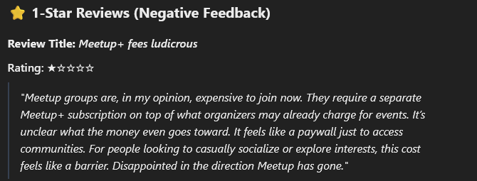
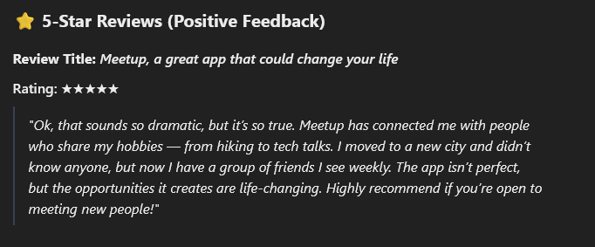

Feel free to delete this whenever!

MeetUp Reviews:
MeetUp has lots of mixed reviews and ratings, but the majority of the ratings are between 4 and 5 stars (66% of ratings were 4 stars and above). Users who rated 4 stars and above appreciated community engagement and saw recent improvements within new API features that allowed translation. Those who rated 3 stars gave it a satisfactory review while those who rated below a 2 reported that the app glitched, had log-in issues, difficulty navigating the interface, and concerns over the app becoming heavily commercialized as well as privacy concerns. Some suggestions that the reviewers had were for the app to address the app’s glitches, technical bugs, and improve the privacy controls and permissions. Additionally, a user mentioned that the app had charged their account a day earlier than expected after a free trial. They stated “I recently signed up for a one-week trial period, however, to my surprise, on the third day of the trial, I discovered that Meetup had charged me an unauthorized amount of $500! I am now faced with the frustrating task of pursuing a refund from their customer support team. I hope that Meetup will address this issue promptly and efficiently, as this experience has left me disappointed in their service.”
Nextdoor Reviews:
Similarly, Nextdoor has lots of mixed reviews, although a majority are 2 stars and lower (55.19% of ratings are 2 stars and below). While users who rated 4 stars and above found the app to have an easy setup process and nice interface, many of the other reviewers found several flaws. Other users who rated 2 stars and below found that the Search and Event pages were often useless, there were privacy concerns over excessive data collection, and moderation over content was a concern as well. Additionally, many users found it hard to get rid of the app and their information within it. They found that they would get continuous emails long after they had deleted their account. For example, a user stated, “Don't sign up!!! The emails you get are absolutely and utterly ridiculous and they make it impossible to unsubscribe. I'm talking several times a day, every day, AFTER I tried to unsubscribe from the hundreds of categories of ‘notifications’”. Meanwhile, some improvements that users suggested were for the Search bar to have better functionality and for privacy concerns to be addressed.

Backup data
(Troy) This is a bit unorthodox, but I believe every major and even minor topic has been broadly addressed in the
“Competitor 1:Meet Up” subtab and “Backup data” appendix is unneccesary for now.

… Because the subtab is already 8 page. ;_;

Yes, it’s only supposed to be 2 pages. But I didn’t expect to address violating the Terms of Service of the Google Play Store just to get user reviews was something I needed to address for my hands-on evaluation. Because apparently it’s “unethical” to scrap user reviews. Thanks chatGPT…

So at this point, this subtab might be for others to dump their own backup data. - Troy.

Citations (if needed, MLA)
Works Cited
“Can Eventbrite’s Growing Ticket Volume Offset Its Widening Losses? Q4 Earnings Analysis.” Eventbrite Q4 Earnings: Revenue Hits $76.5M Despite 13% YoY Decline, Ticket Volume Grows | EB Stock News, StockTitan, 27 Feb. 2025, www.stocktitan.net/news/EB/eventbrite-reports-fourth-quarter-2024-financial-vu47has5pne1.html#:~:text=Eventbrite%20(NYSE%3A%20EB)%20reported,million%20loss%20in%20Q4%202023.
Dkramer@nextdoor.com. “Nextdoor Reports Fourth Quarter and Full Year 2024 Results.” About Nextdoor, 27 Feb. 2025, about.nextdoor.com/press-releases/nextdoor-reports-fourth-quarter-and-full-year-2024-results/.
“Meetup Revenue: Annual, Quarterly, and Historic.” Zippia, 21 July 2023, www.zippia.com/meetup-careers-74297/revenue/#.
“Report: Citizen Business Breakdown & Founding Story: Contrary Research.” Report: Citizen Business Breakdown & Founding Story | Contrary Research, research.contrary.com/company/citizen. Accessed 28 Mar. 2025.
“Snap Inc.. Announces Fourth Quarter and Full Year 2024 Financial Results.” Snap Inc. - Snap Inc. Announces Fourth Quarter and Full Year 2024 Financial Results, investor.snap.com/news/news-details/2025/Snap-Inc.-Announces-Fourth-Quarter-and-Full-Year-2024-Financial-Results/default.aspx. Accessed 28 Mar. 2025.

